

INTELLIGENT SALES AUTOMATION (SAAS) WITH PRESCRIPTIVE LEAD SCORING.
PREPARED BY
ANI CHIDUBEM MICHEAL
B.SC COMPUTER SCIENCE
(22/10799)
SUPERVISED BY
PROF K. MOSES AREGBESOLA
A PROJECT WRITTEN AND SUBMITTED TO THE DEPARTMENT OF COMPUTER SCIENCE, CALEB UNIVERSITY
IN PARTIAL FULFILMENT OF THE REQUIREMENTS FOR THE AWARD OF BACHELOR OF SCIENCE (B.SC) DEGREE IN COMPUTER SCIENCE

DECLARATION
I, Ani Chidubem Micheal (Matric No: 22/10/1799), hereby declare that this project report titled "An Intelligent Sales Automation SaaS with Prescriptive Lead Scoring" is my original work and has not been submitted, either in whole or in part, for any degree or examination at this or any other institution, except where duly acknowledged.

ANI CHIDUBEM MICHAEL ​_______________________
Student's Name​ Signature & Date

CERTIFICATION
This is to certify that this project titled "Intelligent Sales Automation SaaS with Prescriptive Lead Scoring " was carried out by Ani Chidubem (Matric No: 22/10799) in the Department of Computer Science, Caleb University, Imota, Lagos, under my supervision and meets the requirements for the award of the Bachelor of Science (B.Sc.) degree in Computer Science.

Supervisor: Prof K. MOSES AREGBESOLA

Signature: _______________________________ Date: ______________________

Head of Department: Dr. AYORIDE .P. ODUROYE​

Signature: _______________________________ Date: ______________________

DEDICATION
"I can do all things through Christ who strengthens me." — Philippians 4:13
With absolute gratitude, I dedicate this final year project, "Intelligent Sales Automation SaaS with prescriptive Lead Scoring," to Almighty God. His divine grace, guidance, and unwavering faithfulness have been my strength throughout this academic journey.
To my beloved family, thank you for your endless love, prayers, and sacrifices. Your unshakeable belief in me has been my greatest support.
To my supervisor and lecturers, thank you for your valuable mentorship, time, and wisdom.
To my friends and course mates, thank you for the shared determination, collaboration, and support along the way.
May this work serve as a meaningful contribution to the advancement of sales automation and intelligent technology in society today.

ACKNOWLEDGEMENT
I would like to express my sincere gratitude to my supervisor, Prof K. Moses Aregbesola, for the invaluable guidance, patience, and constructive feedback provided throughout the course of this project. My appreciation also goes to the lecturers and staff of the Department of Computer Science, Caleb University, for their support and contributions to my academic development.
My deepest thanks go to my mom, dad, and brother for their constant love, patience, and encouragement. Their sacrifices and steadfast belief in my potential have been the backbone of my academic journey, and I am truly grateful for their presence and support.
I also extend my appreciation to all the lecturers in the Department of Computer Science, with special recognition to Dr. Akanni and Dr Oduroye, for their dedication to teaching and the invaluable knowledge they have imparted over the years.
Finally, I am thankful to my friends Christian Nwanze, Akpan-Ama Favour, and Balogun Faruk, Asuzu Emmanuel, Osilojo John, Chukwuchebem Ijeoma, Nifemi Agboola, Iyanda Simisola, and Okwunalu Peace for their moral support, encouragement, and thoughtful conversations that enriched this research process. Your companionship made this journey both meaningful and memorable.

Abstract
Organizations often face challenges in managing and prioritizing large volumes of sales leads, resulting in inefficient resource allocation and missed business opportunities. This study developed an Intelligent Sales Automation Software-as-a-Service (SaaS) platform that integrates machine learning and workflow automation to improve lead management and support sales decision-making.
The study adopted the Design Science Research (DSR) paradigm, Agile Software Development methodology, and the Cross-Industry Standard Process for Data Mining (CRISP-DM) framework. A Random Forest Classifier was trained using a B2B sales lead dataset to predict the likelihood of lead conversion. Based on the prediction results, leads are automatically classified and assigned appropriate workflow actions.
The system was implemented using React.js, FastAPI, PostgreSQL, and Scikit-learn. Key functionalities include predictive lead scoring, lead classification, automated lead assignment, workflow automation, and sales analytics. The developed platform demonstrates the potential of machine learning and automation in improving lead prioritization and reducing manual effort in sales operations.
The study concludes that intelligent sales automation can enhance the efficiency of lead management processes and support data-driven decision-making in modern organizations.
Keywords: Sales Automation, Machine Learning, Predictive Lead Scoring, Workflow Automation, SaaS.

Table Of Contents
DECLARATION 2
CERTIFICATION 3
DEDICATION 4
ACKNOWLEDGEMENT 5
Abstract 6
Table Of Contents 7
CHAPTER ONE
INTRODUCTION 10
1.1 Background of the Study 10
1.2 Problem Statement 11
1.3 Aim of the Project 12
1.4 Objectives of the Project 12
1.5 Scope of the Project 12
1.6 Limitations of the Study 13
1.7 Significance of the Study 14
1.8 Definition of Key Terms 14
CHAPTER TWO
LITERATURE REVIEW 16
2.1 Introduction 16
2.2 Conceptual Review
2.2.1 Concept of Sales Automation 18
2.2.1 Lead Management Systems 19
2.2.2 Lead Scoring Techniques 21
2.2.3 Predictive Analytics in Sales 24
2.2.4 Machine Learning in Business Prediction 27
2.2.5 Software-as-a-Service (SaaS) Architecture 30
2.3 Empirical Review 33
2.3.1 Studies on Sales Automation Systems 33
Study 1: Chad – AI-Driven Sales Automation and its Impact on Enterprise Software Development 34
Study 2: Trussler – Modern Sales Methodologies and Strategies for B2B Organisations Focused on Digital Products 35
2.3.2 Studies on Predictive Lead Scoring 36
Study 1: Sangam – AI-Powered Lead Scoring and Opportunity Management in Salesforce CRM 36
Study 2: Al Kalach – AI-Driven Customer Relationship Management: Enhancing Salesforce Efficiency Through Predictive Analytics 37
2.3.3 Studies on Machine Learning in CRM Systems 38
Study 1: Sova – Leveraging Artificial Intelligence in SaaS Customer Relationship Management 38
Study 2: Shiramalla – Intelligent Cloud-Based Enterprise Systems Integration Using Salesforce Platforms and Predictive Analytics 40
2.4 Identified Research Gaps 41
Gap 1: Limited Integration of Predictive Scoring with Prescriptive Workflow Automation 41
Gap 2: Limited Research on Accessible SaaS Implementations for Small and Medium Enterprises 42
Gap 3: Lack of Real-Time Prescriptive Automation Frameworks 43
Gap 4: Need for Evaluation Metrics Specific to Combined Prediction-Automation Systems 44
2.5 Summary of Literature Reviewed 44
CHAPTER THREE 48
3.1 Introduction 48
3.2 Research Methodology 49
3.2.1 Design Science Research (DSR) Paradigm 50
3.2.2 Agile Software Development Methodology 51
3.2.3 Cross-Industry Standard Process for Data Mining (CRISP-DM) 52
3.3 System Analysis and Requirements 53
3.3.1 Functional Requirements 54
3.3.2 Non-Functional Requirements 55
3.3.3 Technology Stack 56
3.4 System Architecture 57
3.4.1 System Architectural Overview 59
3.5 Data Collection, Dataset Description and Preprocessing 60
3.5.1 Dataset Source 60
3.5.2 Dataset Description 60
3.5.3 Data Attributes Used 63
3.5.4 Data Preprocessing 64
3.6 Machine Learning Model Design 65
3.7 System Workflow and Automation Design 66
3.8 Database Design 67
3.10 Chapter Summary 69
CHAPTER FOUR 69
SYSTEM IMPLEMENTATION 69
4.1 Introduction 69
4.2 System Implementation 70
4.2.1 Development Environment 71
4.2.2 Frontend Implementation 72
4.2.3 Backend Implementation 73
4.2.4 Machine Learning Implementation 74
4.3 System Interfaces 75
4.3.1 Login Interface 75
4.3.2 Dashboard Interface 76
4.3.3 Lead Import Interface 77
4.3.4 Leads Center Interface 78
4.3.5 Sales Team Interface 79
4.3.6 Team Management Interface 81
4.4 Machine Learning Results 82
4.4.1 Model Training Results 82
4.4.2 Performance Metrics 83
4.4.3 Lead Classification Results 84
4.5 Prescriptive Lead Routing Results 85
4.5.1 Routing Logic Overview 85
4.5.2 Capacity-Based Assignment 86
4.5.3 Load Balancing Mechanism 87
4.6 System Testing and Evaluation 88
4.7 Discussion of Findings 90
4.8 Chapter Summary 91
CHAPTER FIVE 93
SUMMARY, CONCLUSION AND RECOMMENDATIONS 93
5.1 Summary and Conclusion 93
5.2 Recommendations 94
5.3 Suggestions for Further Research 95
References 96

CHAPTER ONE
INTRODUCTION

1.1 Background of the Study
In modern business environments, organizations generate leads from multiple digital and traditional channels such as websites, online advertisements, social media platforms, referrals, and email campaigns. As digital marketing continues to expand, businesses are able to attract a larger number of potential customers than ever before (Chaffey & Ellis-Chadwick, 2019). However, while the volume of leads continues to increase, the ability of sales teams to efficiently manage and prioritize these leads has not improved at the same pace.
In many organizations, lead qualification is still performed manually or through static rule-based systems. Sales representatives often rely on subjective judgment or simple scoring rules, such as assigning points based on job title, company size, or level of engagement. Although these methods provide some structure, they are often inconsistent and may not accurately represent a lead’s true likelihood of conversion (Kotler & Keller, 2016).
As a result, high-potential leads may be overlooked or contacted too late, while low-quality leads consume valuable sales time. This inefficiency reduces overall conversion rates and negatively impacts revenue generation.
Recent advancements in artificial intelligence and machine learning have introduced new approaches for analyzing business data and predicting customer behavior. Predictive analytics techniques enable systems to analyze historical data in order to estimate the probability of future outcomes, such as whether a lead will convert into a paying customer (Provost & Fawcett, 2013). These data-driven methods provide a more objective and scalable way of evaluating sales opportunities.
When integrated into a cloud-based Software-as-a-Service (SaaS) platform, predictive systems can go beyond simply analyzing data. They can also automate operational decisions and trigger appropriate business actions based on prediction results. Such systems allow organizations to improve response time, prioritize high-value opportunities, and optimize the allocation of sales resources (Laudon & Laudon, 2020).
This project therefore focuses on the development of an Intelligent Sales Automation SaaS that combines predictive lead scoring with prescriptive workflow automation in order to improve sales efficiency and decision-making.

1.2 Problem Statement
Despite the availability of Customer Relationship Management (CRM) systems, many organizations still struggle with:
- Poor lead prioritization
- Delayed response to high-value leads
- Manual and repetitive follow-up processes
- Inconsistent lead scoring methods
- Low conversion rates
Most existing systems function primarily as data storage and reporting tools rather than intelligent decision-support systems. They do not dynamically learn from historical data or adapt to changing sales patterns.
Without predictive intelligence, sales teams often allocate resources inefficiently. This leads to lost opportunities, reduced productivity, and revenue leakage.
There is therefore a need for a system that can:
- Accurately predict the likelihood of lead conversion using machine learning techniques.
- Automatically execute predefined workflow actions based on prediction results.
- Provide real-time analytics to support informed sales decisions.
This project seeks to address these challenges by developing an intelligent, web-based Sales Automation SaaS platform.

1.3 Aim of the Project
The aim of this project is to design and implement an Intelligent Sales Automation Software-as-a-Service (SaaS) platform that utilizes machine learning for predictive lead scoring and automates sales workflow actions based on those predictions.

1.4 Objectives of the Project
To achieve this aim, the project will pursue the following objectives:
- To design a scalable SaaS system architecture suitable for multi-user access.
- To develop a machine learning model capable of predicting lead conversion probability.
- To implement a backend system for managing leads and user roles.
- To develop a prescriptive workflow engine that triggers automated actions (e.g., lead routing, alerts, nurturing).
- To design a user-friendly web dashboard for monitoring leads and analytics.
- To evaluate the performance of the predictive model using appropriate metrics.

1.5 Scope of the Project
This project focuses on the design and implementation of a web-based Intelligent Sales Automation SaaS platform that enables organizations to manage and prioritize sales leads using predictive analytics. The system allows businesses to register, create user accounts, and manage lead data within a secure multi-user environment. It collects and stores relevant lead information, applies a machine learning model to estimate the probability of conversion, and classifies leads into categories such as hot, warm, or cold based on predicted scores.
In addition to predictive scoring, the system includes a prescriptive workflow mechanism that automatically triggers predefined sales actions such as lead assignment, notifications, or nurturing processes depending on the predicted outcome. The platform also provides a dashboard interface for monitoring lead performance, viewing analytics, and tracking system activity.
However, the project does not aim to replace full-scale enterprise Customer Relationship Management (CRM) systems. It also does not include complex marketing automation features such as campaign orchestration across multiple advertising platforms. Integration with external third-party enterprise systems is considered outside the scope of this implementation and may be explored as future work.

1.6 Limitations of the Study
Despite its contributions, this study has certain limitations. The predictive model developed in this project relies on available datasets for training and evaluation. Since these datasets may not fully represent all real-world sales environments, the model’s predictive accuracy may vary when applied to different industries or business contexts.
In addition, the system is developed primarily as a prototype to demonstrate the integration of machine learning and automation within a SaaS platform rather than as a full-scale enterprise CRM solution. Advanced enterprise features such as large-scale distributed infrastructure, extensive third-party integrations, and complex marketing automation capabilities are not implemented within this project.
Another limitation is that the performance of predictive models is highly dependent on the quality and completeness of the input data. In situations where data is limited, inconsistent, or noisy, prediction reliability may be affected (Witten et al., 2016). These constraints are acknowledged as part of the academic scope of the study.

1.7 Significance of the Study
This study is significant because it demonstrates how machine learning can be applied to improve sales decision-making through predictive analytics and automation. By replacing manual lead evaluation with data-driven prediction models, the system provides a more objective and consistent approach to lead prioritization.
The integration of predictive lead scoring with automated workflow actions further enhances operational efficiency. Instead of simply analyzing data, the system is capable of initiating appropriate sales actions automatically, thereby reducing response time and improving the allocation of sales resources.
From an academic perspective, this project contributes to research in intelligent information systems, predictive analytics, and cloud-based SaaS application development. From a practical standpoint, it provides a framework that organizations can adopt to improve lead management and increase conversion potential using data-driven automation techniques (Laudon & Laudon, 2020).

1.8 Definition of Key Terms
For clarity and consistency within this study, the following key terms are defined as they apply to the context of this project.
Sales Automation:
Sales automation refers to the use of software systems to automate repetitive sales tasks such as lead management, follow-ups, notifications, and activity tracking, thereby improving efficiency and reducing manual effort.
Lead:
A lead is a potential customer who has shown interest in a company’s product or service and whose information has been captured for possible sales engagement.
Lead Scoring:
Lead scoring is the process of assigning a value or score to a lead based on certain attributes or behaviors in order to determine the likelihood that the lead will convert into a paying customer.
Predictive Analytics:
Predictive analytics refers to the use of statistical and machine learning techniques to analyze historical data and predict future outcomes or behaviors.
Software-as-a-Service (SaaS):
Software-as-a-Service is a cloud-based software delivery model in which applications are hosted online and accessed by users through the internet rather than being installed locally on individual computers.
Lead Conversion:
Lead conversion is the process through which a potential customer (lead) becomes an actual paying customer after engaging with the sales process.
Prescriptive Automation:
Prescriptive automation refers to systems that not only predict outcomes but also recommend or automatically execute actions based on those predictions.

CHAPTER TWO
LITERATURE REVIEW

2.1 Introduction
The increasing digitization of business processes and the growing volume of customer data have fundamentally transformed how organizations approach sales and customer relationship management. As established in Chapter One, modern businesses generate leads from multiple digital channels, yet many sales teams continue to rely on manual or static rule-based systems for lead qualification. This disconnect between data availability and decision-making capability has created a pressing need for intelligent systems that can not only analyze customer data but also automate appropriate sales actions. This chapter presents a comprehensive review of existing literature relevant to the development of an Intelligent Sales Automation SaaS platform with prescriptive lead scoring capabilities.
The primary purpose of this literature review is to establish a theoretical and empirical foundation for the study by examining prior research across several interconnected domains. These include sales automation systems, lead management and scoring methodologies, predictive analytics and machine learning applications in business contexts, and Software-as-a-Service (SaaS) architecture considerations. By synthesizing findings from these diverse but related fields, this chapter aims to identify established knowledge, recognize current gaps in the literature, and position the present study within the broader academic discourse.
The scope of this literature review encompasses both conceptual and empirical works published primarily between 2015 and 2026, reflecting the rapid evolution of artificial intelligence and machine learning technologies in business applications. Foundational texts from earlier periods are included where they provide essential theoretical frameworks or historical context. The literature was sourced from multiple academic databases including Google Scholar, IEEE Xplore, ScienceDirect, and ACM Digital Library, using keywords such as "sales automation," "predictive lead scoring," "machine learning in CRM," "prescriptive analytics," and "SaaS architecture." Additionally, recent industry publications and technical reports were consulted to ensure relevance to contemporary practice.
The literature is organized into two main parts to facilitate clear understanding. Part A presents the conceptual review, which systematically examines the key concepts underlying this study. Beginning with the concept of sales automation (2.2.1), the review progresses through lead management systems (2.2.2), lead scoring techniques both traditional and predictive (2.2.3), predictive analytics in sales (2.2.4), machine learning applications for business prediction (2.2.5), and finally the architectural principles of Software-as-a-Service platforms (2.2.6). This conceptual progression moves from the broader domain of sales automation to the specific technical components required for implementing an intelligent lead scoring system.
Part B presents the empirical review, which examines actual research studies and their findings. This section analyzes empirical studies on sales automation systems (2.3.1), predictive lead scoring implementations (2.3.2), and machine learning applications within Customer Relationship Management systems (2.3.3). Each empirical study is examined in terms of its objectives, methodology, key findings, and relevance to the current project. This analysis reveals patterns, contradictions, and gaps in the existing research that help justify and guide the present study.
Following the conceptual and empirical reviews, the chapter presents a synthesis of the literature (2.4) that integrates findings across all reviewed areas. This is followed by identification of specific research gaps (2.5) that the current project aims to address. A conceptual framework for the study (2.6) is then developed, showing the relationships between key constructs and how they inform the system design. Finally, the chapter concludes with a summary (2.7) that connects the literature review findings to the research objectives outlined in Chapter One.
This literature review thus serves multiple functions: it demonstrates familiarity with existing scholarship, establishes theoretical grounding for the project, identifies the unique contribution of the current study, and provides a foundation for the methodology and system design to be presented in subsequent chapters.

2.2 Conceptual Review
2.2.1 Concept of Sales Automation
Sales automation represents a shift from manual, labour-intensive sales activities toward technology-enabled workflows that improve efficiency and effectiveness. Chad (n.d., p. 1) defines AI-driven sales automation as the use of artificial intelligence technologies, including machine learning, natural language processing, and predictive analytics, to streamline and enhance sales processes such as lead generation, customer segmentation, forecasting, and follow-up management. This evolution is closely linked to the digitisation of business processes, with Trussler (2025, p. 1) noting that the modern B2B sales landscape is now characterised by digital engagement and data-driven decision-making, a significant departure from the traditional approaches that defined earlier decades.
Sales automation systems typically incorporate four core technologies. Machine learning and predictive analytics analyse historical data and customer behaviour to identify high-value leads, optimise pricing, and improve conversion rates. Natural language processing and AI-powered chatbots enable real-time customer interaction, lead qualification, and automated follow-ups. Robotic Process Automation handles repetitive rule-based tasks such as data entry, lead assignment, and record updates, reducing manual errors and improving workflow efficiency. AI-enhanced CRM systems provide personalised recommendations by analysing customer interactions and engagement history to support upselling, cross-selling, and retention strategies.
The organisational benefits of sales automation are well documented. Chad (n.d., pp. 3-4) identifies increased productivity, improved lead scoring, enhanced personalisation, and reduced forecasting errors as primary advantages. Duarte et al. (2023, p. 4) further note that AI-powered automation enables higher conversion rates, improved customer retention, and optimised resource allocation, while also presenting challenges related to data privacy, ethical AI use, and legacy system integration.
It is also important to distinguish sales automation from marketing automation. While marketing automation addresses broader customer acquisition and nurturing activities, sales automation directly supports the consultative role of sales professionals by reducing administrative burden and enabling greater focus on strategic engagement (Trussler, 2025, p. 2).

2.2.1 Lead Management Systems
Lead management encompasses the processes and systems used to capture, track, qualify, and distribute potential customers as they progress through the sales funnel. Sangam (2026, p. 1) positions it as foundational to sales success, describing lead scoring and opportunity management as critical functions in customer acquisition and revenue generation.
The Lead Lifecycle
The lead lifecycle covers six stages. Lead generation identifies potential customers through channels such as websites, social media, referrals, and email campaigns, with Magomadov (2025, p. 9) noting a shift from volume-driven cold calling toward data-based and predictive processes. Lead capture involves systematically collecting and storing contact, company, and source data within CRM systems to prevent what Laaksonen (2024, as cited in Magomadov, 2025, p. 12) describes as the "sales lead black hole," where over 70% of generated leads are never acted upon. Lead qualification assesses leads against defined criteria to determine sales readiness, with traditional frameworks such as BANT increasingly being supplemented by AI-driven predictive scoring. Lead distribution assigns qualified leads to appropriate sales representatives, either through rule-based criteria or predictive models. Lead nurturing maintains engagement with leads not yet ready for conversion through targeted communications. Lead conversion represents the ultimate objective, transforming a qualified prospect into a paying customer.
Challenges in Traditional Lead Management
Sangam (2026, p. 1) identifies several persistent challenges. Inaccurate prioritisation, resulting from static rule-based criteria and manual judgment, leads to misallocation of sales resources. Delayed conversions arise from slow qualification and distribution processes, which directly reduces response speed and conversion success. Data quality issues further compound these problems, as incomplete contact or firmographic information causes sales representatives to deprioritise or abandon leads entirely (Magomadov, 2025, p. 11).
CRM and Sales Intelligence Integration
Modern lead management is closely integrated with CRM platforms, which Buttle and Maklan (2019, as cited in Magomadov, 2025, p. 10) describe as centralised repositories that support interaction tracking and relationship management across the buyer journey. AI-enhanced CRM systems improve this further by providing continuously updated information that enables more accurate prospecting and timely engagement. Specialised sales intelligence platforms such as Lusha, ZoomInfo, Apollo, and Cognism extend these capabilities through prospect data enrichment, intent signal monitoring, and CRM integration, enabling sales teams to prioritise and personalise outreach more effectively (Magomadov, 2025, pp. 20-22).

2.2.2 Lead Scoring Techniques
Lead scoring is the process of ranking prospects based on their likelihood to convert into paying customers, enabling sales teams to focus effort on the most valuable opportunities while reducing sales cycle duration and operational costs (Sangam, 2026, p. 1). Beyond prioritisation, effective scoring provides a shared language for marketing and sales alignment, supports more accurate sales forecasting, and contributes to improved Customer Lifetime Value through reduced churn and increased subscription value (Popoola & John, n.d., p. 3).
Traditional Lead Scoring Methods
Traditional scoring approaches fall into three categories. Explicit scoring assigns point values to demographic and firmographic attributes such as job title, company size, and industry. Implicit scoring evaluates prospect behaviour through indicators such as email opens, website visits, content downloads, and webinar attendance, recognising that engagement intensity often correlates with purchase intent. Rule-based scoring combines both approaches through manually configured point systems, where cumulative thresholds determine when a lead is considered sales-ready.
Despite widespread adoption, these methods carry notable limitations. Sangam (2026, p. 1) notes that rule-based systems struggle to adapt to dynamic customer behaviour and evolving market conditions, as manually defined rules quickly become outdated. Al Kalach (2025, p. 4) further highlights that manual scoring is inherently subjective and biased toward the opinions of individual sales representatives, resulting in inconsistency across evaluations. Additionally, simple point systems cannot capture complex interactions between attributes, and without feedback mechanisms, scoring accuracy does not improve over time.
Predictive Lead Scoring
Predictive lead scoring addresses these limitations by applying machine learning to develop data-driven models of conversion likelihood. Sangam (2026, p. 2) explains that machine learning models learn complex, non-linear relationships from historical CRM, behavioural, and transactional data, enabling dynamic lead prioritisation based on real-time signals. These models follow a supervised learning approach, trained on historical data with known conversion outcomes, and subsequently estimate conversion probabilities for new leads by identifying patterns consistent with prior successful conversions.
Commonly applied algorithms include logistic regression, valued for its interpretability; Random Forests and gradient boosting methods such as XGBoost and LightGBM, which excel at capturing feature interactions and handling heterogeneous or high-dimensional data; and Support Vector Machines, effective in specific contexts involving complex feature-outcome relationships (Sangam, 2026, p. 4). Al Kalach (2025, p. 5) reports that predictive scoring delivers 30 to 40% higher lead conversion rates compared to traditional approaches, driven by greater objectivity, adaptability through continuous retraining, scalability across large lead volumes, and the ability to identify non-obvious patterns that human judgment would overlook.
Feature Engineering and Model Evaluation
The effectiveness of predictive models depends on the quality of input features. Sangam (2026, p. 4) identifies key feature categories including temporal indicators such as recency of engagement, aggregated behavioural metrics such as total website visits and average email open rates, cross-channel signals spanning email, web, and social media activity, and derived attributes created by combining raw variables into higher-order measures. Popoola and John (n.d., p. 4) further note that high engagement metrics and feature adoption trends serve as strong indicators of upsell potential, extending scoring utility beyond initial conversion.
Model performance is assessed using accuracy, precision, recall, and F1-score, supplemented by lift charts and precision-recall analysis to guard against misleading accuracy in low-conversion datasets. Interpretability is equally important, with techniques such as feature importance analysis and SHAP values used to explain model outputs to sales and marketing stakeholders (Sangam, 2026, p. 4).
From Scoring to Action
When integrated with CRM and sales automation platforms, predictive scores trigger automated workflows, routing high-scoring leads to sales representatives, initiating nurturing sequences for mid-range leads, and deprioritising low-scoring prospects. Sangam (2026, p. 6) concludes that machine learning-based lead scoring becomes a powerful enabler of scalable and personalised customer engagement when supported by governed data pipelines, forming the foundation for systems that not only predict outcomes but also automate appropriate responses.

2.2.3 Predictive Analytics in Sales
Predictive analytics represents a shift from retrospective reporting toward anticipating future outcomes to proactively shape sales activities. Al Kalach (2025, p. 3) defines it as the application of data, statistical algorithms, and AI-based models to recognise the probability of future outcomes based on historical data, transforming CRM platforms from passive repositories into intelligent decision-support systems.
Analytics Taxonomy
Sova (2026, p. 23), drawing on Lepenioti et al. (2020), situates predictive analytics within a three-tier taxonomy. Descriptive analytics examines what has happened, using historical data to identify patterns and trends in customer behaviour. Predictive analytics addresses what will happen, utilising historical and real-time data to forecast customer behaviours such as purchase likelihood and churn risk. Prescriptive analytics extends this further by recommending optimal actions, simulating multiple scenarios to determine the most suitable course of action. The progression across these three tiers represents an organisational analytics maturity journey, with each stage building on the capabilities of the previous.
Applications in Sales
Predictive analytics supports several distinct sales functions. In lead scoring and conversion prediction, predictive models analyse demographic attributes, behavioural signals, and historical conversion patterns to estimate purchase likelihood, with Al Kalach (2025, p. 5) reporting 30 to 40% higher conversion rates compared to traditional approaches. In sales forecasting, predictive models analyse historical trends, pipeline velocity, and market factors to deliver 25 to 35% improved forecast accuracy over manual methods (Al Kalach, 2025, p. 5). Churn prediction identifies customers exhibiting cancellation risk signals such as declining usage or payment failures, enabling proactive retention interventions (Popoola & John, n.d., p. 3). Customer Lifetime Value forecasting projects the total expected revenue from a customer relationship, supporting informed decisions on acquisition costs and retention investments (Popoola & John, n.d., p. 3). Next-best-action recommendations suggest contextualised sales actions such as follow-ups, content sharing, or tailored pricing based on patterns from historical engagements (Sangam, 2026, p. 5). Cross-selling and upselling models identify customers most likely to respond positively to expansion offers by analysing usage patterns and feature adoption behaviour (Popoola & John, n.d., p. 3).
Techniques
The core techniques underpinning predictive sales analytics include supervised machine learning algorithms such as regression, Random Forests, and gradient boosting; Natural Language Processing for extracting intent and sentiment signals from unstructured text; clustering and segmentation methods for grouping customers by behavioural similarity; and time series analysis for capturing seasonality and cyclical patterns in sales data (Al Kalach, 2025, p. 4).
Benefits and Challenges
The adoption of predictive analytics improves sales productivity through automated prioritisation, enhances customer experience through personalised engagement, supports strategic resource allocation, and drives revenue growth through improved conversion and retention rates (Al Kalach, 2025, p. 6). However, implementation presents challenges. Model reliability depends heavily on data quality, as incomplete or biased data produces unreliable predictions (Kihu et al., 2022, p. 10). Complex models can function as black boxes, undermining stakeholder trust and adoption. Integration into existing workflows requires technical redesign, and the use of customer data raises compliance considerations under regulations such as GDPR and CCPA.
Future Directions
Al Kalach (2025, p. 11) identifies several emerging trends shaping the field, including hyper-personalisation through real-time context-aware engagement, the broader adoption of prescriptive analytics for automated decision-making, real-time customer insight processing from streaming data, and the growing emphasis on ethical and explainable AI to maintain regulatory compliance and customer trust.

2.2.4 Machine Learning in Business Prediction
Machine learning has emerged as a transformative technology for business prediction, enabling organisations to extract actionable insights from complex datasets. Kihu et al. (2022, p. 13) define it as a branch of artificial intelligence that uses data and algorithms to imitate human learning, gradually improving accuracy over time. Unlike traditional programmed systems, machine learning algorithms modify themselves during runtime to minimise error as new data becomes available.
Types of Machine Learning
For business prediction purposes, machine learning applications fall into two primary categories. Classification involves assigning data to discrete categories, such as predicting whether a lead will convert or a customer will churn. Regression models continuous numeric outputs such as revenue forecasts, customer lifetime value, or optimal pricing estimates (Sangam, 2026, p. 4). Both approaches rely predominantly on supervised learning, where models are trained on labelled historical data with known outcomes.
Classification Algorithms
Several algorithms have proven effective for lead scoring and business classification tasks. Logistic regression estimates conversion probability as a function of input features and is favoured for its interpretability, though its assumption of linear feature relationships limits its capacity to capture complex patterns (Sangam, 2026, p. 4). Decision trees classify instances through a series of Boolean splits, handling both numerical and categorical data with high interpretability, but are prone to overfitting and perform poorly on edge cases (Kihu et al., 2022, pp. 16-17). Random Forests address these limitations by constructing ensembles of shallow trees and determining classification through majority voting, with each tree trained on a random feature subset to improve diversity and reduce misclassification risk. Sangam (2026, p. 4) notes that tree-based ensemble methods provide higher predictive accuracy by capturing interactions among demographic, engagement, and behavioural attributes, though at the cost of reduced interpretability compared to single decision trees (Kihu et al., 2022, p. 18). Gradient boosting machines, including XGBoost and LightGBM, build trees sequentially with each iteration correcting prior errors, excelling at handling heterogeneous feature sets, missing values, and high-dimensional CRM data (Sangam, 2026, p. 4). Neursu et al. (2025, p. 4) report gradient boosting achieving 92.5% accuracy compared to 90.3% for Random Forests and 87.8% for logistic regression in churn prediction tasks. Support Vector Machines construct separating hyperplanes between classes and can be effective for high-dimensional data, though Kihu et al. (2022, p. 66) report SVM accuracies of 64 to 80% for lead classification, generally below Random Forest performance.
Regression Algorithms
For continuous prediction targets, linear regression models the relationship between independent variables and numeric outcomes and remains valued for its interpretability, though it assumes linear feature relationships that are often violated in complex business data (Kihu et al., 2022, p. 14). Neural networks, composed of interconnected layers of processing units, can model highly complex non-linear relationships but require substantial data, are computationally intensive, and offer limited interpretability. Kihu et al. (2022, p. 33) report neural networks achieving a lower mean squared error than linear regression for customer lifetime prediction, though prediction errors remained approximately 3.3 months against an average customer lifetime of eight months.
Model Evaluation
Classification performance is assessed using accuracy, precision, recall, and F1-score. Kihu et al. (2022, p. 25) caution that accuracy alone is unreliable in imbalanced datasets, where a model predicting the majority class for all instances can achieve high accuracy while providing no practical value. Matthews Correlation Coefficient is recommended as a more balanced metric, as it equally prioritises both classes in binary classification tasks. For regression models, Mean Squared Error and R-squared are used together to evaluate predictive accuracy and variance explained. To ensure generalisation to unseen data, K-Fold Cross Validation is commonly employed, dividing the dataset into K subsets and rotating the evaluation fold across K training cycles (Kihu et al., 2022, p. 24).
Feature Engineering and Interpretability
Model effectiveness depends critically on input feature quality. Key feature engineering techniques include creating derived variables from raw interaction data, applying mathematical transformations to address skewed distributions, selecting the most predictive features through permutation importance analysis, and dimensionality reduction using methods such as Principal Component Analysis, though Kihu et al. (2022, p. 57) found that dimensionality reduction reduced accuracy compared to using the full feature set in their study.
Model interpretability is increasingly important for business adoption. Sangam (2026, p. 4) highlights feature importance analysis, SHAP values, and partial dependence plots as key techniques for explaining why individual leads receive particular scores, thereby improving stakeholder trust, transparency, and regulatory compliance.
Machine Learning in CRM
The integration of machine learning with CRM systems represents a significant advancement in sales technology. Sangam (2026, p. 1) observes that CRM platforms are evolving from passive data repositories into intelligent decision systems capable of predicting customer intent and guiding sales actions. Sova (2026, p. 21) describes AI-integrated CRM systems as platforms that adapt to inserted data using AI applications, enriching core CRM capabilities with segmentation, automation, and personalisation features derived from large-scale data analysis.

2.2.5 Software-as-a-Service (SaaS) Architecture
Software-as-a-Service represents a fundamental shift in how software is delivered and consumed. Rather than requiring local installation, SaaS delivers software over the internet through a subscription-based model. Sova (2026, p. 32) describes it as cloud-based software licensed to customers via the internet, with access provided through web browsers or APIs, eliminating the need for local hardware or IT infrastructure.
Key Characteristics
SaaS platforms are distinguished by five core characteristics. Subscription-based pricing replaces one-time licence fees with recurring payments, aligning vendor incentives with ongoing customer value delivery. Multi-tenancy allows a single software instance to serve multiple customers simultaneously, with data logically separated but infrastructure shared, enabling economies of scale and simplified maintenance (Shiramalla, n.d., p. 3). Centralised management places hosting, updates, and security responsibilities with the vendor, relieving customers of operational burdens. Scalability enables rapid capacity expansion through cloud infrastructure without proportional IT investment. Accessibility allows users to connect from any location, supporting distributed and global workforces. Sova (2026, p. 33) notes that these characteristics have democratised access to sophisticated business applications, particularly for small and medium-sized organisations previously constrained by high infrastructure costs.
Architecture Components
Modern SaaS platforms are structured across four functional layers. The data ingestion layer captures information from multiple sources including CRM systems, ERP platforms, and external APIs, supporting both real-time and batch processing (Shiramalla, n.d., p. 5). The integration and middleware layer manages data transformation and routing through an API-led connectivity approach, organised into system APIs that provide standardised access to core systems, process APIs that orchestrate business logic, and experience APIs that deliver tailored outputs to specific interfaces (Shiramalla, n.d., p. 6). The analytics and intelligence layer houses predictive models and machine learning services that generate actionable insights, with results feeding back into operational systems to create closed-loop intelligence. The presentation layer provides the user interface through which customers interact with the platform, with predictive insights embedded directly into workflows to support real-time decision-making (Sangam, 2026, p. 4).
Scalability and API Design
Scalability is addressed through horizontal scaling, load balancing, caching, database optimisation techniques such as indexing and sharding, and asynchronous processing for resource-intensive operations (Shiramalla, n.d., p. 2). APIs serve as the connective tissue of SaaS platforms, with RESTful design remaining the most widely adopted standard. Event-driven mechanisms and webhooks enable near real-time data synchronisation, ensuring that lead profiles and customer records remain continuously updated as behaviours evolve (Sangam, 2026, p. 3).
Security and Compliance
SaaS platforms handling customer data must address substantial security and privacy obligations. Key requirements include data encryption in transit and at rest, role-based identity and access management, tenant isolation to prevent cross-customer data leakage, and comprehensive audit logging for compliance monitoring. Sova (2026, p. 31) highlights that failure to comply with regulations such as GDPR and CCPA can carry significant consequences, making compliance a critical architectural constraint rather than an optional consideration.
Benefits and Challenges
The SaaS model offers measurable advantages for business applications, including reduced time to value through immediate deployment, lower upfront costs through subscription pricing, automatic updates, elastic scalability, and broad ecosystem integration capabilities. Sova (2026, p. 34) further notes that SaaS platforms continuously accumulate usage and transaction data, creating opportunities for analytics-driven improvement that are difficult to replicate in traditional software environments.
Challenges include data sovereignty requirements that may constrain infrastructure geography, vendor lock-in arising from integration dependencies, internet connectivity reliance, and the complexity of balancing multi-tenancy efficiency with adequate tenant isolation and customisation. Sova (2026, p. 33) acknowledges that the relative rigidity of SaaS products can be mitigated through marketplace ecosystems that allow customisation without compromising core platform integrity.
The proposed Intelligent Sales Automation platform embodies these SaaS principles, delivering lead scoring and workflow automation through a multi-tenant, web-based architecture that scales to accommodate growing user volumes while maintaining data isolation, security, and continuous improvement capabilities.

2.3 Empirical Review
While the conceptual review established the theoretical foundations for sales automation, lead scoring, predictive analytics, machine learning, and SaaS architecture, the empirical review examines how these concepts have been applied and validated through actual research studies. This section analyzes empirical investigations into sales automation systems, predictive lead scoring implementations, and machine learning applications within Customer Relationship Management systems. Each study is examined in terms of its objectives, methodology, key findings, and relevance to the current project, providing evidence-based insights that inform the design and development of the proposed intelligent sales automation platform.

2.3.1 Studies on Sales Automation Systems
Empirical research on sales automation systems has explored their impact on sales performance, user adoption, and organizational outcomes. This subsection reviews key studies that investigate how automation technologies transform sales processes and the factors that influence their successful implementation.

Study 1: Chad – AI-Driven Sales Automation and its Impact on Enterprise Software Development
Chad (n.d.) conducted a conceptual review synthesising existing literature and industry observations to examine how AI-driven sales automation transforms enterprise software development and sales processes, with particular focus on machine learning, natural language processing, predictive analytics, robotic process automation, and AI-powered CRM systems.
The study identified several key findings. AI technologies significantly reduce manual effort and improve accuracy, enabling businesses to achieve improved efficiency and personalisation across lead generation, customer segmentation, and sales forecasting (Chad, n.d., p. 1). Integrating AI into enterprise systems requires developers to design scalable, cloud-based architectures with robust API integrations and adaptive learning models as core components rather than optional additions (p. 4). The research also highlighted persistent implementation challenges, including data privacy concerns, legacy system integration, and dependence on high-quality data, which must be addressed for successful deployment (pp. 5-6).
This study is relevant to the current project as its identification of key enabling technologies aligns directly with the components of the proposed platform. The emphasis on scalable cloud-based architectures supports the SaaS delivery model adopted in this study, while the challenges identified around data quality and system integration inform the risk mitigation considerations applied during development.

Study 2: Trussler – Modern Sales Methodologies and Strategies for B2B Organisations Focused on Digital Products
Trussler (2025) employed a qualitative research design using semi-structured interviews with five experienced SaaS sales professionals conducted during spring 2025. Data were analysed using thematic analysis following the framework of Braun and Clarke (2006), with participants selected through purposeful sampling to represent diverse roles, company sizes, and geographical regions.
The study produced four notable findings. B2B SaaS sales have shifted away from rigid frameworks toward hybrid, adaptive methodologies emphasising consultative and value-driven engagement, with participants describing traditional outbound approaches as increasingly ineffective (Trussler, 2025, p. 14). Buyer behaviour has become markedly more autonomous and digitally informed, with prospects arriving already knowledgeable about products and competitors, requiring sales professionals to deliver immediate value rather than product-led pitches (p. 16). AI tools and automation platforms such as ChatGPT, Clay, and Lavender have been widely adopted for prospecting, personalisation, and outreach execution, significantly reducing the time required to generate and customise communications (p. 17). Despite this, participants cautioned against over-reliance on automation, noting that the most effective strategies combine data-driven tools with personalised, trust-based engagement rather than prioritising volume over quality (p. 18).
These findings are relevant to the current project in several respects. The emphasis on human-assisted rather than fully automated sales activity suggests the proposed platform should support sales professionals through intelligent recommendations rather than replacing their judgment. The finding that buyers expect timely and personalised engagement further reinforces the importance of accurate lead scoring, while the range of AI tools identified provides practical context for feature design and workflow automation development.

2.3.2 Studies on Predictive Lead Scoring
Predictive lead scoring represents one of the most significant applications of machine learning in sales. This subsection reviews empirical studies that have developed, tested, and validated predictive models for lead scoring and related applications.

Study 1: Sangam – AI-Powered Lead Scoring and Opportunity Management in Salesforce CRM
Sangam (2026) employed a system architecture design approach, proposing a multi-layer framework for AI-powered lead scoring with Salesforce CRM as the central intelligence and orchestration layer. The architecture spans data ingestion, feature engineering, machine learning intelligence, CRM automation, and governance, drawing on established machine learning principles and CRM integration patterns to validate the proposed design.
The study produced four key findings. Effective AI-powered lead scoring requires a layered architecture in which customer data, machine learning intelligence, and automated sales workflows converge within a single operational platform, ensuring predictive insights are embedded directly into sales execution (Sangam, 2026, p. 2). Supervised learning algorithms, including logistic regression, decision trees, Random Forests, and gradient boosting machines, form the foundation of most lead scoring systems by learning conversion patterns from labelled historical data (p. 4). Model explainability is critical for business adoption, with techniques such as feature importance analysis, SHAP values, and partial dependence plots applied to help stakeholders understand why individual leads receive particular scores (p. 4). The architecture also incorporates a dedicated governance and monitoring layer to address bias, security, and regulatory compliance requirements (p. 2).
This study is directly relevant to the current project. The layered architectural approach provides a structural template for the proposed platform, while the emphasis on real-time scoring and closed-loop optimisation aligns with the prescriptive automation objectives of this study. The focus on model explainability also addresses the trust and adoption considerations identified across the reviewed literature.

Study 2: Al Kalach – AI-Driven Customer Relationship Management: Enhancing Salesforce Efficiency Through Predictive Analytics
Al Kalach (2025) employed a review methodology, synthesising industry evidence, vendor documentation, and organisational case studies to examine how predictive analytics addresses the limitations of traditional CRM models, including data silos, manual reporting, and inaccurate forecasting.
The study produced five key findings, several supported by quantitative benchmarks. Predictive lead scoring delivers 30 to 40% higher conversion rates compared to manual, subjective ranking by sales representatives (Al Kalach, 2025, p. 4). AI-enhanced sales forecasting improves accuracy by 25 to 35% through real-time incorporation of market and customer signals, outperforming traditional static spreadsheet approaches (p. 4). Across broader business performance metrics, AI-driven CRM contributes a 20% increase in sales productivity, 15 to 30% improvement in customer retention, and 30 to 40% reduction in customer service costs (p. 5). The study also identifies key AI-driven CRM features and their operational outcomes, including predictive lead scoring for conversion improvement, opportunity insights for reducing deal slippage, and automated workflow assistants for productivity enhancement (p. 4). Identified implementation challenges include data privacy and security concerns, algorithmic bias, legacy system integration, workforce adoption barriers, and ethical risks, all of which require deliberate mitigation strategies (p. 5).
This study is relevant to the current project as its quantitative benchmarks establish measurable performance targets for the predictive lead scoring component. The documented feature functions provide concrete reference points for platform design, while the identified challenges directly inform the risk assessment and mitigation considerations applied throughout system development.

2.3.3 Studies on Machine Learning in CRM Systems
The integration of machine learning with CRM systems represents a significant advancement in sales technology. This subsection reviews empirical studies examining how ML enhances CRM capabilities and the factors influencing successful implementation.

Study 1: Sova – Leveraging Artificial Intelligence in SaaS Customer Relationship Management
Sova (2026) employed qualitative content analysis of secondary, publicly available data, collecting 42 customer stories from seven AI-enhanced CRM vendors, including Salesforce, Microsoft, HubSpot, Pipedrive, Zendesk, Oracle, and Zoho, with SaaS companies as the client base. Analysis followed Schreier's (2012) iterative content analysis process, using both deductive and inductive coding frames developed with NVivo software.
The study produced five notable findings. A comprehensive framework was developed categorising AI-CRM functionalities into four types: data integration and insight creation, resource coordination and workflow optimisation, customer engagement support, and organisational enablement (Sova, 2026, pp. 46-47). SaaS organisations pursue both operational objectives, including efficient resource allocation and personalised customer engagement, and strategic objectives, including data-driven decision-making and organisational scalability (pp. 51-58). Internal challenges such as technical and infrastructural limitations were more frequently documented than external ones, appearing in 23 of the 42 analysed stories (p. 59). AI-supported resource coordination and workflow optimisation was the most cited functionality, appearing in 26 of 42 stories, encompassing automated lead routing, task assignment, interaction summarisation, and routine task automation, suggesting that operational efficiency is the primary driver of AI adoption in this context (pp. 65-67). A processual model further demonstrates how AI-enabled CRM objectives contribute to organisational scalability through improvements in data integration, resource coordination, and customer engagement (p. 71).
This study is relevant to the current project in several respects. The AI functionality framework provides a reference for evaluating the proposed platform's feature scope, while the finding that internal efficiency drives adoption reinforces the importance of the prescriptive automation component alongside predictive accuracy. The processual model also offers theoretical grounding for the platform's value proposition.

Study 2: Shiramalla – Intelligent Cloud-Based Enterprise Systems Integration Using Salesforce Platforms and Predictive Analytics
Shiramalla (n.d.) employed a system architecture design approach with case study validation, proposing a multi-layer integration framework that combines Salesforce as the central orchestration hub with MuleSoft as integration middleware. The architecture encompasses data ingestion from multiple enterprise sources, API-led connectivity organised into system, process, and experience layers, and closed-loop predictive analytics modelling, validated through a retail industry case study.
The study produced four key findings. The proposed multi-layer architecture successfully integrates diverse enterprise systems while embedding predictive intelligence, enabling seamless connectivity across data ingestion, middleware, analytics, and presentation layers (Shiramalla, n.d., p. 5). API-led connectivity organised across layered API tiers improves scalability and simplifies change management while supporting real-time integration through event-driven architecture (p. 6). The retail case study demonstrated measurable outcomes including a 45 to 55% reduction in data synchronisation latency, approximately 20% improvement in demand forecast accuracy, and approximately 10% reduction in customer churn (p. 8). Key implementation challenges included data quality issues, change management resistance, and the need for user training to build stakeholder trust in AI-driven predictions (p. 7).
This study is relevant to the current project as the layered architectural approach provides a practical reference for the proposed platform's technical design. The emphasis on API-led connectivity supports integration with existing CRM systems, while the quantitative outcomes from the case study offer benchmarks for evaluating the impact of the proposed system. The identified challenges further inform risk mitigation considerations during development.

2.4 Identified Research Gaps
The comprehensive review of literature presented in this chapter has revealed significant advances in sales automation, predictive lead scoring, machine learning applications, and SaaS architecture. However, critical examination of existing research also exposes important gaps that warrant further investigation. This section identifies these gaps and demonstrates how the current study is positioned to address them.

Gap 1: Limited Integration of Predictive Scoring with Prescriptive Workflow Automation
While substantial research has demonstrated the effectiveness of predictive models for lead scoring and churn prediction, significantly less attention has been devoted to connecting these predictions with automated workflow actions. Sangam (2026, p. 2) describes an architecture where predictive scores are embedded into CRM objects and trigger actions such as lead routing and sales alerts, but this remains a conceptual proposal rather than an empirically validated implementation. Kihu et al. (2022, p. 88) acknowledge that their models successfully predict customer behavior but do not extend to automating responses based on those predictions. Shiramalla (n.d., p. 7) calls for "closed-loop architecture" where predictions inform actions and outcomes feed back into model refinement, yet provides limited guidance on implementing such loops in practice.
This gap is particularly significant given the emerging consensus that prediction alone delivers only partial value. As Al Kalach (2025, p. 11) observes, the future of AI-driven CRM lies in moving "from predictive to prescriptive analytics," where AI not only forecasts outcomes but also recommends optimal actions. However, empirical research on prescriptive automation in sales contexts remains scarce. The current study addresses this gap by designing and implementing a system that not only predicts lead conversion probability but also automatically executes predefined workflow actions based on those predictions—such as lead routing, notifications, and nurturing process initiation.

Gap 2: Limited Research on Accessible SaaS Implementations for Small and Medium Enterprises
The preponderance of research on AI-powered CRM and sales automation focuses on enterprise-scale implementations, particularly those centered on Salesforce and other major platforms serving large organizations. Al Kalach (2025) and Sangam (2026) both examine Salesforce-specific implementations, while Shiramalla (n.d.) proposes architectures assuming substantial enterprise IT infrastructure. Kihu et al. (2022) worked with an established data analytics company serving enterprise clients. This enterprise focus leaves a significant gap in understanding how smaller organizations with limited technical resources and budgets can benefit from predictive sales automation.
Sova (2026, p. 11) explicitly notes that "AI-CRM implementation is highly industry-specific and that developing a comprehensive, general model is difficult," yet even his study examines customer stories from primarily established vendors. Magomadov (2025, p. 2) addresses SDR workflows but focuses on a single sales intelligence platform rather than comprehensive automation. The current study addresses this gap by developing a web-based SaaS platform designed for accessibility, with multi-user support and a user-friendly dashboard that does not require extensive IT infrastructure or specialized technical expertise to deploy and use.

Gap 3: Lack of Real-Time Prescriptive Automation Frameworks
Existing research on predictive sales systems predominantly operates in batch mode, where models are trained on historical data and predictions are generated periodically. Kihu et al. (2022, p. 64-65) made a significant contribution by demonstrating that recent data (last 3 months) is more predictive than early data, yet their analysis remained retrospective. Sangam (2026, p. 2) proposes "real-time data orchestration" and "near real-time ingestion" but provides limited implementation guidance for achieving true real-time prescriptive automation.
Popoola and John (n.d., p. 7) identify "real-time personalization with AI" as a future trend, noting that "with the rise of streaming analytics and event-driven architectures, SaaS platforms can analyze user behavior as it happens and dynamically adjust recommendations, offers, or product experiences." However, they acknowledge that current systems largely operate in batch-oriented modes. Trussler (2025, p. 17-18) found that sales professionals increasingly use AI tools for outreach and personalization, but these tools primarily support human activities rather than enabling real-time automated responses.
The current study addresses this gap by designing a system capable of generating lead scores in real-time as new lead data becomes available and triggering appropriate workflow actions without human intervention. This real-time prescriptive capability represents a significant advance over batch-oriented predictive systems documented in existing literature.

Gap 4: Need for Evaluation Metrics Specific to Combined Prediction-Automation Systems
Existing research provides robust frameworks for evaluating predictive model performance. Kihu et al. (2022, p. 24-25) extensively employ accuracy, Matthew's Correlation Coefficient, precision, recall, and F1-score for classification models, and mean squared error and R-squared for regression models. Sangam (2026, p. 4) discusses feature importance analysis and SHAP values for model interpretability. Neursu et al. (2025, p. 4) use A/B testing to evaluate intervention effectiveness. However, no established framework exists for evaluating systems that combine prediction with automated action—specifically, how to measure the effectiveness of the end-to-end system rather than just its predictive components.
This gap is significant because prediction accuracy alone does not guarantee business value. A highly accurate predictive model might trigger inappropriate actions, or automated actions might be poorly designed even if predictions are correct. The current study contributes to addressing this gap by proposing and applying evaluation metrics that assess both predictive accuracy and the effectiveness of automated workflow actions triggered by those predictions.

2.5 Summary of Literature Reviewed
This chapter reviewed literature spanning sales automation, lead management, predictive analytics, machine learning, and SaaS architecture, identifying key themes, empirical evidence, and research gaps that collectively position and justify the current study.
Synthesis of Key Themes
The literature reveals a clear evolutionary trajectory from manual, rule-based sales processes toward intelligent systems that leverage machine learning to automate, predict, and prescribe. Chad (n.d., p. 1) defines AI-driven sales automation as the integration of machine learning, natural language processing, and predictive analytics to streamline lead generation, segmentation, and forecasting. Lead scoring, described by Sangam (2026, p. 1) as the process of ranking prospects based on conversion likelihood, emerges as central to effective lead management, yet traditional rule-based approaches remain limited by static criteria, subjective judgment, and inability to capture complex buying signals.
Sova (2026, p. 23), drawing on Lepenioti et al. (2020), situates this evolution within an analytics maturity model progressing from descriptive through diagnostic, predictive, and prescriptive levels, with each stage building on the capabilities of the previous. Machine learning provides the technical foundation for predictive capability, with key algorithms including logistic regression for interpretability, Random Forests and gradient boosting for capturing non-linear feature interactions, and neural networks for complex pattern recognition (Kihu et al., 2022, p. 13). At the delivery level, SaaS architecture supports modern sales platforms through multi-tenancy, centralised management, scalability, and API-led connectivity across layered data ingestion, integration, analytics, and presentation components (Shiramalla, n.d., pp. 5-6).
Empirical Evidence for Predictive Lead Scoring
Multiple studies provide quantitative support for predictive over traditional approaches. Al Kalach (2025, p. 4) reports 30 to 40% higher conversion rates with AI-driven lead scoring compared to manual methods. Kihu et al. (2022, p. 65) demonstrate Random Forest achieving 88.7% accuracy and an MCC of 0.763 for churn prediction, while Neursu et al. (2025, p. 4) report gradient boosting reaching 92.5% accuracy, with AI-driven interventions reducing churn by 10% and increasing feature usage by 15% in controlled testing.
Feature engineering consistently influences model performance. Kihu et al. (2022, p. 57) found that models using derived fields outperformed those relying on raw data alone, with recurring revenue metrics identified as the most predictive features. Across studies, ensemble methods outperformed single classifiers, and recency of engagement proved more predictive than early interaction patterns, a finding with direct implications for lead scoring feature design (Kihu et al., 2022, pp. 64-65).
The Emerging Focus on Prescriptive Automation
The literature increasingly emphasises connecting predictions with automated action. Sangam (2026, p. 2) describes a CRM orchestration layer that operationalises AI insights by triggering lead routing and priority assignments, while Shiramalla (n.d., p. 7) proposes a closed-loop architecture where prediction outcomes feed back into model refinement. Trussler (2025, pp. 17-18) found that existing AI tools primarily support human activity rather than enabling fully automated responses, underscoring the opportunity for systems that combine predictive accuracy with automated execution.
SaaS-Specific Considerations
SaaS contexts present unique conditions for AI-CRM implementation. Sova (2026, p. 34) notes that continuous collection of usage, transaction, and interaction data creates data-rich environments well suited to predictive modelling. Resource coordination and workflow optimisation emerged as the most frequently implemented AI functionality across 26 of 42 analysed customer stories, indicating that internal operational efficiency is the primary driver of adoption (Sova, 2026, pp. 65-67).
Challenges and Success Factors
The literature identifies data quality and integration as primary implementation concerns (Shiramalla, n.d., p. 7; Magomadov, 2025, p. 11). Model interpretability is critical for user trust and adoption (Sangam, 2026, p. 4), while privacy and compliance obligations under regulations such as GDPR impose constraints on data usage (Al Kalach, 2025, p. 5). User training and change management are further identified as essential for overcoming adoption resistance (Trussler, 2025, p. 18).
How the Current Study Addresses Identified Gaps
The study addresses four gaps identified in Section 2.4. Gap 1, concerning limited integration of predictive scoring with prescriptive workflow automation, is addressed by implementing a system that not only predicts conversion probability but automatically executes workflow actions based on those predictions. Gap 2, concerning limited research on accessible SaaS implementations for SMEs, is addressed through a web-based platform with multi-user support and a user-friendly dashboard that requires no specialised IT infrastructure. Gap 3, concerning the lack of real-time prescriptive automation frameworks, is addressed by designing the system to generate scores and trigger workflow actions in real time as new lead data becomes available. Gap 4, concerning the need for evaluation metrics specific to combined prediction-automation systems, is addressed by applying metrics that assess both predictive accuracy and the effectiveness of automated workflow outcomes.
Together, the reviewed literature confirms that predictive lead scoring delivered through SaaS architecture can significantly enhance sales effectiveness, while the identified gaps establish a clear rationale for the design, implementation, and evaluation of the proposed Intelligent Sales Automation platform.

CHAPTER THREE

3.1 Introduction
This chapter presents the methodology adopted for the design and development of the Intelligent Sales Automation SaaS platform. It describes the research approaches, development methodologies, system design techniques, and technological tools used in implementing the proposed solution. The chapter also explains the system architecture, data collection process, dataset preparation procedures, machine learning model design, workflow automation mechanism, and database structure employed in the project.
To ensure a systematic and structured development process, the study adopts the Design Science Research (DSR) paradigm as the overarching research approach. The software application is developed using the Agile methodology, which supports iterative development and continuous refinement of system features. In addition, the machine learning component follows the Cross-Industry Standard Process for Data Mining (CRISP-DM) framework, providing a structured approach for data preparation, model development, and evaluation.
The proposed system integrates predictive analytics and workflow automation within a Software-as-a-Service (SaaS) environment to improve lead management and sales decision-making. Historical lead data is processed through a machine learning model to predict the likelihood of lead conversion. Based on the generated prediction scores, the system automatically classifies leads and executes predefined workflow actions such as lead assignment and follow-up recommendations.
This chapter further presents the system requirements, proposed system design, technology stack, system architecture, data preprocessing techniques, machine learning model development process, workflow engine design, and database design that collectively form the foundation of the Intelligent Sales Automation SaaS platform.

3.2 Research Methodology
Research methodology refers to the systematic procedures, techniques, and approaches adopted to achieve the objectives of a study. The selection of an appropriate methodology is essential because it provides a structured framework for conducting research, developing solutions, and evaluating outcomes. In this project, three complementary methodologies were employed to guide different aspects of the system development process. These include the Design Science Research (DSR) paradigm, the Agile Software Development Methodology, and the Cross-Industry Standard Process for Data Mining (CRISP-DM) framework.
The Design Science Research paradigm serves as the overarching research approach, providing a framework for the creation and evaluation of an innovative software artifact. The Agile methodology guides the iterative development of the web-based SaaS application, while CRISP-DM provides a structured process for developing and evaluating the machine learning model used for predictive lead scoring. By integrating these methodologies, the project addresses both the software engineering and machine learning requirements of the proposed Intelligent Sales Automation SaaS platform.

3.2.1 Design Science Research (DSR) Paradigm
Design Science Research is a paradigm focused on the creation and evaluation of artifacts designed to solve organisational and technological problems (Hevner et al., 2004). It was adopted in this study because the project involves designing and implementing an Intelligent Sales Automation SaaS platform to address challenges in manual lead qualification, inconsistent prioritisation, and delayed sales decision-making.
The DSR process was applied across six activities. Problem identification examined the limitations of existing lead management practices, revealing inefficiencies in manual evaluation, resource allocation, and the limited use of predictive intelligence. From this, objectives were defined to develop a system capable of predicting lead conversion probability and automating workflow actions based on those predictions. The design and development stage produced the full platform, encompassing the system architecture, database structure, machine learning model, workflow engine, and user interface. Demonstration confirmed that the system can process lead data, generate conversion predictions, classify leads into priority tiers, and execute predefined workflow actions. Evaluation assessed system effectiveness through machine learning performance metrics and software testing, with a focus on prediction accuracy and decision support capability. Finally, communication involved documenting the research process, design decisions, and evaluation outcomes through this report.
DSR provides a suitable framework for this study as it validates both the technical artifact and its practical contribution to intelligent sales operations.

3.2.2 Agile Software Development Methodology
The Agile Software Development Methodology was adopted for this project due to its iterative and incremental approach, which emphasises flexibility, collaboration, and the continuous delivery of functional software components (Beck et al., 2001). Unlike sequential methodologies, Agile allows features to be progressively developed, tested, and refined across short development cycles.
Two factors drove this choice. The platform integrates multiple components, including a web application, machine learning model, workflow automation engine, and relational database, making incremental development essential for continuous testing and integration. Additionally, intelligent system development requires adaptability, as insights from model evaluation may necessitate adjustments to business rules, workflows, or the user interface throughout the project lifecycle.
The development process followed eight sequential activities: requirements analysis and planning; system architecture design; frontend development using React.js and Vite; backend API development using FastAPI; database implementation using PostgreSQL; machine learning model development and integration; workflow automation implementation; and system testing and refinement.
This iterative approach ensured that all system components were progressively improved and effectively integrated throughout development.

3.2.3 Cross-Industry Standard Process for Data Mining (CRISP-DM)
The machine learning component was developed using the Cross-Industry Standard Process for Data Mining (CRISP-DM) framework, a widely recognised methodology that provides a structured approach for transforming raw data into predictive insights (Chapman et al., 2000). The framework comprises six phases, each contributing to the development of an effective predictive model.
Business understanding established the primary objective: predicting lead conversion likelihood to support intelligent sales decision-making through automated prioritisation. Data understanding involved examining the lead dataset and identifying relevant attributes across organisational, engagement, behavioural, financial, and acquisition categories. Data preparation covered cleaning and transforming the dataset, including handling missing values, encoding categorical variables, and selecting relevant features for model training. During the modelling phase, a Random Forest Classifier was selected and trained on historical lead data due to its capacity to handle complex feature relationships and classification tasks. Evaluation assessed model performance using Accuracy, Precision, Recall, F1-Score, and ROC-AUC metrics to verify predictive capability and reliability. Deployment and integration involved embedding the trained model into the SaaS platform, where it processes lead data, generates conversion probability scores, and enables workflow automation.
The adoption of CRISP-DM ensures the machine learning component is developed through a structured and repeatable process, improving the reliability of the predictive lead scoring system.

3.3 System Analysis and Requirements
System analysis examines an existing problem domain to identify user needs and define the requirements necessary for an effective solution. In this study, the analysis focused on how organisations currently manage sales leads, prioritise opportunities, and allocate sales resources, with particular attention to the limitations of manual qualification processes and the absence of intelligent decision-support capabilities in traditional systems.
Organisations generate leads from multiple sources, including websites, social media, email campaigns, referrals, and digital advertisements. As lead volumes grow, many sales teams continue to rely on manual evaluation or basic rule-based methods to assess lead quality. These approaches are time-consuming, inconsistent, and unreliable in identifying high-potential opportunities, often resulting in sales effort being directed toward low-quality leads while stronger prospects receive insufficient attention. Furthermore, conventional lead management systems are largely focused on storing contact information and tracking interactions rather than providing predictive or automated support, which limits their contribution to conversion rate improvement and sales efficiency.
The proposed Intelligent Sales Automation SaaS platform was designed to address these limitations by integrating machine learning-based lead scoring with workflow automation. The system predicts lead conversion likelihood, classifies leads into priority tiers, and automates assignment and follow-up processes, thereby reducing manual effort and improving the overall quality of sales decision-making.

3.3.1 Functional Requirements
The functional requirements define the specific services and capabilities that the Intelligent Sales Automation SaaS platform must provide to its users.
FR1: User Authentication and Authorization – The system shall support user registration and login with role-based access control distinguishing between Admin and Sales Agent roles using JWT-based authentication and bcrypt password hashing.
FR2: Lead Data Ingestion – The system shall support bulk lead upload through CSV file import and individual lead entry through manual form submission, with validation of required lead information before storage.
FR3: Lead Management – The system shall allow users to view, search, filter, and manage lead records through a centralized dashboard.
FR4: Predictive Lead Scoring – The system shall process lead data using a trained machine learning model and generate conversion probability scores for individual leads.
FR5: Lead Classification – The system shall classify leads into Hot, Warm, and Cold categories based on their predicted conversion probability.
FR6: Automated Lead Assignment – The system shall automatically assign leads to appropriate sales personnel based on lead classification and predefined workflow rules.
FR7: Workflow Automation – The system shall execute predefined workflow actions, including lead routing, follow-up recommendations, and lead nurturing processes.
FR8: Lead Details Management – The system shall allow users to view detailed information associated with individual leads, including prediction scores and assignment status.
FR9: Analytics Dashboard – The system shall provide visual analytics and reporting features for monitoring lead distribution, prediction outcomes, and sales performance indicators.
FR10: Lead Assignment Tracking – The system shall maintain records of lead assignments and workflow actions for monitoring and auditing purposes.

3.3.2 Non-Functional Requirements
The non-functional requirements define the quality attributes and operational characteristics of the proposed system.
NFR1: Performance – The system shall generate lead predictions and respond to user requests within an acceptable response time under normal operating conditions.
NFR2: Reliability – The system shall provide consistent and accurate operation with minimal system downtime and data loss.
NFR3: Security – The system shall protect user accounts and lead information through secure authentication, password encryption, and controlled access mechanisms.
NFR4: Scalability – The system shall accommodate increasing numbers of users and lead records without significant degradation in performance.
NFR5: Usability – The system shall provide an intuitive and user-friendly interface that enables users to perform tasks with minimal training.
NFR6: Maintainability – The system shall be designed using modular components to facilitate future updates, enhancements, and bug fixes.
NFR7: Data Integrity – The system shall ensure that lead information, prediction results, and assignment records remain accurate and consistent throughout system operations.
NFR8: Compatibility – The system shall be accessible through modern web browsers and support responsive usage across different device screen sizes.
NFR9: Availability – The system shall be available to authorized users whenever required, subject to scheduled maintenance activities.

3.3.3 Technology Stack
The platform was built using a set of modern technologies selected for their performance, scalability, and compatibility with the project requirements.
The frontend was developed using React.js for its component-based architecture and efficient rendering, Vite as the build tool for improved development speed, Bootstrap 5 for responsive and consistent interface design, and Chart.js for visualising lead statistics and sales analytics.
The backend was built with Python as the primary programming language and FastAPI as the web framework, chosen for its high performance, automatic API documentation, and seamless integration with Python-based machine learning systems.
The machine learning component was developed using Scikit-learn for model training and evaluation, Pandas for data manipulation and preprocessing, and NumPy for numerical computations.
The database layer utilises PostgreSQL as the relational database management system and SQLAlchemy as the Object Relational Mapping (ORM) framework to facilitate communication between the backend and the database.
Security is enforced through JSON Web Tokens (JWT) for authentication and session management, and bcrypt for password hashing and secure credential storage.

3.4 System Architecture
System architecture refers to the high-level structure of a system and the manner in which its various components interact to achieve the desired functionality. It provides a blueprint that defines the organization of software modules, data flow, communication mechanisms, and system responsibilities.
The Intelligent Sales Automation SaaS platform adopts a multi-layered architecture consisting of the Client Layer, Application Layer, Machine Learning Layer, and Database Layer. This architectural approach promotes modularity, maintainability, scalability, and efficient separation of concerns. Each layer performs specific functions while interacting with other layers to support lead management, predictive analytics, workflow automation, and reporting activities.
The architecture enables users to interact with the system through a web interface, while backend services process requests, execute business logic, generate predictions, and manage data storage. Figure 3.1 presents the high-level architecture of the proposed system.
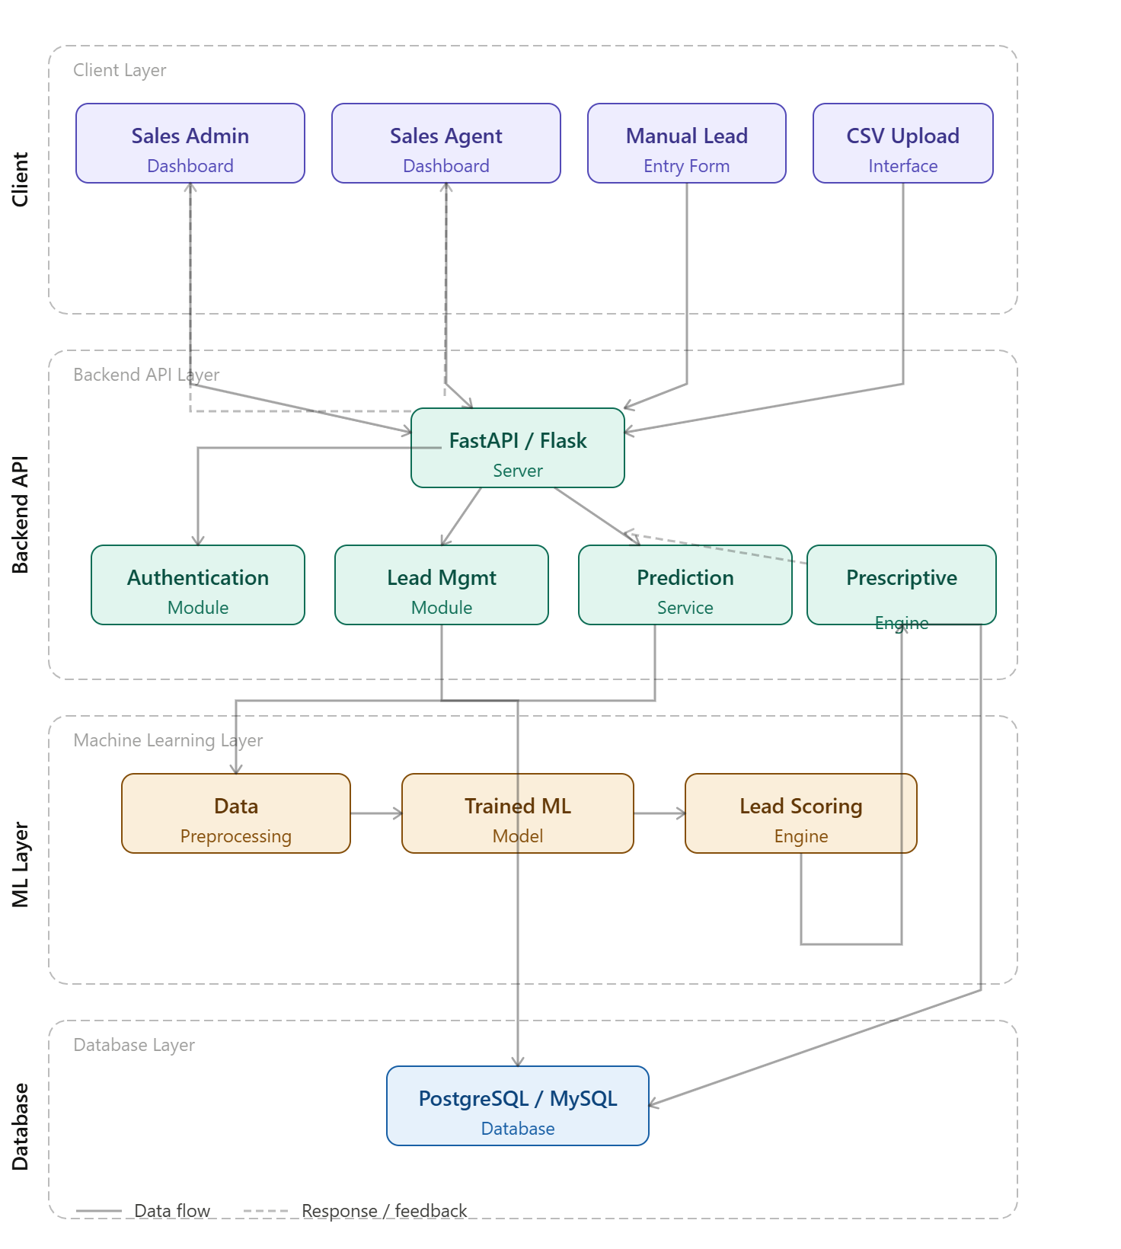
Figure 3.1
Proposed System Architecture

3.4.1 System Architectural Overview
The platform is structured across four layers, each with distinct responsibilities that together support the full operation of the system.
The Client Layer, built with React.js, Vite, and Bootstrap 5, serves as the user-facing interface through which administrators and agents perform all interactions ,including lead uploads, viewing prediction results, monitoring assignments, and accessing analytical dashboards.
The Application Layer, developed using FastAPI and Python, forms the core processing component of the system. It handles user authentication and authorisation, lead data validation, business rule execution, workflow management, and coordinates communication between all other layers.
The Machine Learning Layer contains the trained Random Forest model, which receives lead data from the Application Layer, processes relevant attributes across five categories ,organisational, engagement, behavioural, financial, and acquisition ,and returns a conversion probability score. Based on this score, leads are classified into three tiers: Hot (80–100%), Warm (50–79%), or Cold (below 50%), after which workflow automation rules are applied.
The Database Layer, powered by PostgreSQL and accessed via SQLAlchemy ORM, serves as the central data repository for user accounts, lead records, prediction scores, assignment records, and system logs. It ensures data consistency and supports efficient retrieval across all system operations.
This layered architecture maintains a clear separation of responsibilities while enabling efficient communication between components.

3.5 Data Collection, Dataset Description and Preprocessing
The performance of a machine learning system is largely dependent on the quality and relevance of the data used during model development. Consequently, data collection and preprocessing are critical stages in the development of predictive systems. This section describes the dataset used in this study, its characteristics, the selected data attributes, and the preprocessing techniques applied to prepare the data for machine learning model training and evaluation.
The dataset used in this project consists of historical B2B sales lead records containing organizational, engagement, behavioral, financial, and lead acquisition information. These attributes were utilized to train the predictive lead scoring model responsible for estimating the likelihood of lead conversion.

3.5.1 Dataset Source
The dataset used for this study is the B2B Sales Lead Dataset, a synthetic dataset designed to simulate real-world business-to-business sales lead scenarios. The dataset contains lead information commonly utilized in sales and customer acquisition processes, including company characteristics, engagement metrics, purchasing indicators, and conversion outcomes.
The dataset was selected because it contains diverse lead attributes relevant to lead qualification and conversion prediction tasks. Furthermore, the dataset provides sufficient records for training and evaluating a supervised machine learning model.

3.5.2 Dataset Description
The dataset contains 5,000 lead records and 28 attributes, including the target variable used for classification. The records represent individual sales leads and their associated characteristics collected throughout the sales process.
The target variable, Converted, indicates whether a lead was successfully converted into a customer. This variable serves as the dependent variable during model training and evaluation. Table 3.1 presents the complete dataset schema table:
Column Name | Data Type | Category | Description
lead_id | VARCHAR | Lead Information | Unique identifier assigned to each lead
first_name | VARCHAR | Lead Information | Lead's first name
last_name | VARCHAR | Lead Information | Lead's last name
email | VARCHAR | Lead Information | Business email address of the lead
phone_number | VARCHAR | Lead Information | Contact phone number in Nigerian format (+234 xxx xxx xxxx)
job_title | VARCHAR | Professional & Organizational | Professional role or job position of the lead
seniority_level | ENUM | Professional & Organizational | Organizational level (C-Suite, VP, Director, Manager, Staff)
department | VARCHAR | Professional & Organizational | Department within the organization
country | VARCHAR | Professional & Organizational | Country or geographical region of the lead
company_name | VARCHAR | Professional & Organizational | Name of the organization
company_industry | ENUM | Professional & Organizational | Industry sector of the company
company_size_category | ENUM | Professional & Organizational | Company classification (Startup, SMB, Mid-Market, Enterprise)
company_size_range | VARCHAR | Professional & Organizational | Estimated employee size range of the organization
estimated_annual_revenue | FLOAT | Professional & Organizational | Estimated yearly company revenue in millions
lead_source | ENUM | Lead Acquisition | Source through which the lead was acquired
date_captured | DATE | Lead Acquisition | Date the lead entered the system
website_visits | INTEGER | Behavioral & Engagement | Total number of visits to the company website
pages_viewed | INTEGER | Behavioral & Engagement | Number of website pages viewed by the lead
average_time_on_site | FLOAT | Behavioral & Engagement | Average session duration on the website in minutes
email_open_rate | FLOAT | Behavioral & Engagement | Percentage of marketing emails opened by the lead
email_click_rate | FLOAT | Behavioral & Engagement | Percentage of clicked email links
webinar_attendance | BOOLEAN | Behavioral & Engagement | Indicates whether the lead attended a webinar
last_interaction_days | INTEGER | Behavioral & Engagement | Number of days since the last interaction
meeting_scheduled | BOOLEAN | Behavioral & Engagement | Indicates whether a sales meeting was scheduled
follow_up_status | ENUM | Behavioral & Engagement | Lead response after sales follow-up (Positive, Neutral, Negative, No Response)
estimated_budget | ENUM | Financial & Purchase Intent | Estimated purchasing budget level (Low, Medium, High)
purchase_timeline | ENUM | Financial & Purchase Intent | Expected timeframe for a purchasing decision
converted | BOOLEAN | Target Variable | Indicates whether the lead converted into a customer (1 = Converted, 0 = Not Converted)
Table 3.1 Database Schema
Table 3.2 presents a summary of the dataset characteristics.
Attribute | Description
Dataset Name | B2B Sales Lead Dataset
Dataset Type | Structured Tabular Dataset
Number of Records | 5,000
Number of Features | 28
Learning Type | Supervised Learning
Prediction Task | Binary Classification
Target Variable | Converted
Table 3.2 Summary of Dataset Characteristics

3.5.3 Data Attributes Used
The model draws on 20 lead attributes across five categories, selected for their predictive value in conversion outcomes.
Organizational attributes capture company-level context: job title, seniority level, industry, company size, and estimated annual revenue. Engagement attributes reflect digital interaction history, website visits, pages viewed, time on site, email open and click rates, webinar attendance, and content downloads. Behavioral signals indicate purchasing intent, covering demo requests, scheduled meetings, follow-up responses, and days since last interaction. Financial attributes include estimated budget and purchase timeline, while Lead Acquisition attributes record the lead source and date captured.
Together, these attributes form a profile of each lead's organizational standing, engagement depth, and conversion readiness.

3.5.4 Data Preprocessing
Raw data was cleaned prior to model training by verifying attribute formats, removing duplicate records, standardizing categorical values, validating numerical fields, and flagging incomplete records. These steps improved dataset consistency and reduced potential sources of prediction error. Missing values were identified and addressed using appropriate imputation techniques, minimizing information loss while keeping all records available for training.
Since machine learning algorithms require numerical input, categorical attributes, including job title, seniority level, company industry, company size, and lead source ,were encoded into numerical representations, enabling the Random Forest model to process them alongside continuous features.
Feature selection was then applied to retain only attributes most relevant to lead conversion: those reflecting lead qualification, engagement behavior, purchasing intent, and organizational profile. This reduced model complexity without sacrificing predictive power.
Finally, the dataset was split into training and testing subsets using an 80:20 ratio. The training portion allowed the model to learn relationships between lead attributes and conversion outcomes, while the held-out test set provided an unbiased measure of generalization performance on unseen records.

3.6 Machine Learning Model Design
The machine learning component of the proposed system is responsible for predicting the likelihood of lead conversion based on historical lead characteristics. The model was developed using supervised learning techniques, where historical lead records and their conversion outcomes were used to learn predictive patterns.
A Random Forest Classifier was selected as the predictive model due to its effectiveness in handling classification problems, ability to manage complex feature relationships, and robustness against overfitting. The model was trained using the prepared dataset and evaluated using standard classification metrics, including Accuracy, Precision, Recall, F1-Score, and ROC-AUC.
The prediction generated by the model is expressed as a conversion probability score. Based on this score, leads are automatically categorized into three priority levels:
- Hot Leads: 80% – 100%
- Warm Leads: 50% – 79%
- Cold Leads: Below 50%
These classifications provide the foundation for the workflow automation processes implemented within the system.

3.7 System Workflow and Automation Design
Lead data enters the system through bulk dataset uploads via the CSV interface or manual entry through the lead input form. Upon receipt, the data undergoes preprocessing, including format validation, categorical attribute encoding, and missing value handling, before being submitted to the trained Random Forest model for inference.
The model produces a conversion probability score for each lead record, which determines its classification into one of three priority tiers: hot, warm, or cold. This classification is passed to the workflow automation engine, which applies predefined routing and assignment rules corresponding to each tier. Hot leads are escalated to the sales team for immediate direct engagement. Warm leads are routed into a structured follow-up sequence, with assigned agents prompted to maintain contact at regular intervals. Cold leads are directed to nurturing workflows, including scheduled email sequences or targeted content delivery, designed to sustain engagement and re-qualify leads over time.
All outputs, including the probability score, classification tier, and assigned workflow action, are stored in the database and reflected on the dashboard interface. Administrators are provided with an overview of lead distribution across tiers and workflow execution status, while agents receive a prioritised list of assigned leads alongside recommended next actions. Manual override is supported where sales judgment requires deviation from automated assignments.
This pipeline reduces reliance on manual decision-making, shortens lead response times, and ensures sales effort is directed toward leads with the greatest conversion potential.
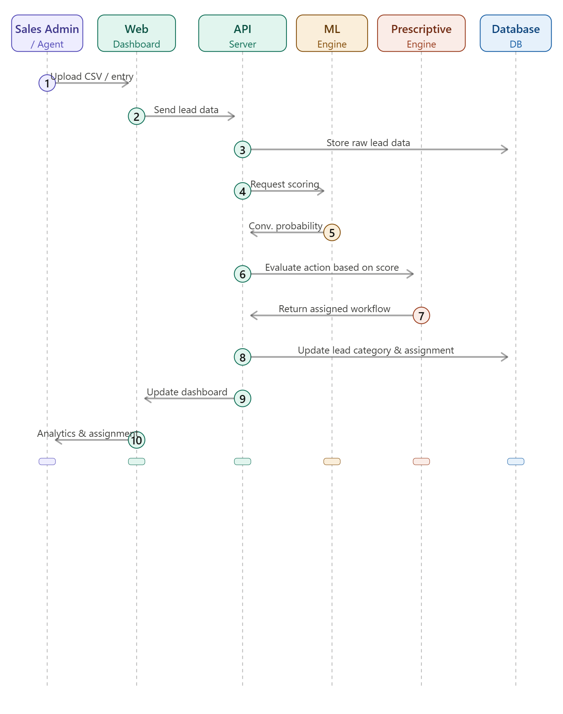
Figure 3.2
System Workflow of the Intelligent Sales Automation SaaS Platform

3.8 Database Design
The proposed system utilizes a PostgreSQL relational database to store and manage application data. The database was designed to ensure data integrity, efficient retrieval, and effective management of lead-related information.
The database consists of four primary entities: Users, Leads, Lead Scores, and Lead Assignments. The Users entity stores authentication and role information for system users. The Leads entity maintains lead details and associated attributes used for prediction. The Lead Scores entity stores prediction outcomes generated by the machine learning model, while the Lead Assignments entity records lead allocation and workflow actions.
The relationships among these entities support lead management, predictive analytics, and workflow automation functionalities within the system.
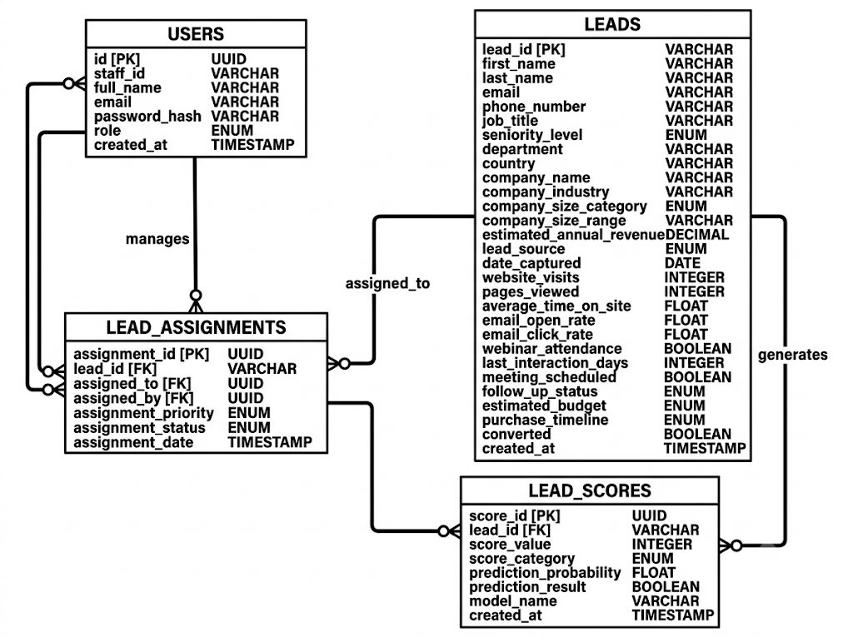
Figure 3.3
Entity Relationship Diagram of the Proposed System
Table | Description
Users | Stores user account and role information
Leads | Stores lead records and lead attributes
Lead Scores | Stores prediction scores and lead classifications
Lead Assignments | Stores lead assignment and workflow information
Table 3.3
Primary Database Tables

3.10 Chapter Summary
This chapter presented the methodology adopted for the development of the Intelligent Sales Automation SaaS platform. The Design Science Research paradigm provided the overall research framework, while Agile methodology guided system development and CRISP-DM supported the machine learning process. The chapter further discussed the system requirements, proposed system design, technology stack, system architecture, dataset preparation procedures, machine learning model design, workflow automation mechanism, system workflow, and database design. These components collectively provide the foundation for the implementation and evaluation of the proposed system, which are presented in the subsequent chapter.

CHAPTER FOUR

SYSTEM IMPLEMENTATION

4.1 Introduction
This chapter presents the implementation of the Intelligent Sales Automation SaaS platform, a web-based system developed to automate B2B lead management through the integration of machine learning and workflow automation. The system was designed to address the limitations of manual lead qualification processes by providing automated lead scoring, prescriptive lead routing, and real-time sales team monitoring within a role-based multi-tenant environment.
The implementation consists of two primary operational environments. The first is the Admin Revenue Operations Environment, which supports lead ingestion, AI-powered lead scoring, sales team configuration, lead assignment, and system monitoring. The second is the Sales Member Environment, which provides sales representatives with a role-scoped workspace for managing and acting on assigned leads.
The platform was developed using a client-server architecture. The frontend was implemented using React.js, while FastAPI provides backend services through RESTful APIs. PostgreSQL serves as the primary database management system, and a trained Random Forest Classifier powers the predictive lead scoring engine. Role-based access control mechanisms were implemented across both the frontend and backend to ensure secure access to system resources.
The chapter is organized as follows. Section 4.2 discusses the system implementation, including the development environment, frontend, backend, and machine learning components. Section 4.3 presents the major system interfaces. Section 4.4 reports the machine learning model results, while Section 4.5 discusses the prescriptive lead routing outcomes. Section 4.6 presents system testing and evaluation results. Section 4.7 discusses the findings of the study, and Section 4.8 concludes the chapter with a summary.

4.2 System Implementation

4.2.1 Development Environment
The system was developed on a local machine running Windows 11, with all components hosted on localhost during development and testing. Table 4.1 presents the minimum hardware specifications required to run the system, while Table 4.2 lists the core software tools used across the project.
Component | Specification
Processor | Intel Core i5 (8th Generation) or equivalent
RAM | 8 GB (16 GB recommended for ML training)
Storage | 20 GB available disk space
Operating System | Windows 10/11, macOS 12+, or Ubuntu 20.04+
Table 4.1
Minimum Hardware Requirements
Software | Version | Purpose
Python | 3.11+ | Backend development and ML model training
Node.js | 18+ | Frontend build tooling
PostgreSQL | 14+ | Relational database management
Git | 2.40+ | Version control
npm | 9+ | JavaScript package management
Table 4.2
Core Software Dependencies

The complete technology stack was selected to support the three major system components: the frontend interface, the backend API, and the machine learning pipeline. Table 4.3 summarizes the key technologies used across each component.
Component | Technology | Role
Frontend | React 18, TypeScript, Material UI | User interface development
Frontend | Vite 6 | Development server and build tool
Frontend | React Router DOM, Zustand | Routing and state management
Backend | FastAPI, Uvicorn | REST API and server runtime
Backend | SQLAlchemy 2.0, Alembic | Database ORM and schema migrations
Backend | python-jose, passlib | JWT authentication and password hashing
Database | PostgreSQL 14+ | Persistent data storage
ML Pipeline | scikit-learn, pandas, joblib | Model training, preprocessing, and serialization
File Handling | python-multipart, openpyxl | CSV and Excel file parsing
Table 4.3
System Technology Stack
Version control was managed using Git throughout the development lifecycle, with the project repository maintained on GitHub. This allowed changes to be tracked across the frontend, backend, and machine learning components in a structured manner.

4.2.2 Frontend Implementation
The frontend was built as a React 18 Single Page Application (SPA) using Vite 6 as the build tool and TypeScript for type safety. Material UI (MUI) was used as the primary component library, providing a consistent and responsive interface across all screens. The application communicates with the backend exclusively through a configured Axios HTTP client that attaches JWT authentication tokens to all outgoing requests.
The frontend is organized around two role-based environments. Administrators have access to the full platform including lead import, team configuration, team management, and the leads center. Sales members are restricted to a scoped view of only their assigned leads and their personal performance dashboard. This role separation is enforced at the routing level, meaning unauthorized users are redirected automatically before any restricted page loads.
The main screens implemented in the frontend include the login and registration pages, the admin and sales dashboards, the leads center, the lead detail view, the CSV import interface, the sales team configuration page, and the team management workload page. Navigation between these screens is handled through a persistent left sidebar that renders menu items dynamically based on the authenticated user's role.

4.2.3 Backend Implementation
The backend was implemented using FastAPI, a Python-based web framework that supports asynchronous request handling and automatic API documentation generation. All endpoints are served under the /api/v1 prefix and are organized into separate modules for authentication, lead management, user management, dashboard statistics, invitations, and machine learning prediction.
User authentication is based on a Staff ID and password credential scheme. When a user logs in, the system verifies the provided credentials using bcrypt password comparison, validates the user's role, and issues a JSON Web Token (JWT) that expires after 60 minutes. All protected endpoints require this token to be included in the request header. Passwords are never stored in plain text; they are hashed using the bcrypt algorithm before being saved to the database.
The backend manages four main areas of business logic. Lead management handles the creation, retrieval, and status updates of lead records. The CSV import pipeline processes uploaded files row by row, invokes the machine learning model on each lead, and saves all results to the database with an unassigned status. The prescriptive lead routing engine assigns leads to sales members based on a structured evaluation of each representative's profile, capacity, and performance. The dashboard module aggregates statistics for both administrators and sales members, including lead counts, tier distributions, and assignment summaries.
Sales members are onboarded through an invitation-based system. An administrator generates an invitation link that is sent to the sales representative. The link contains a signed token that allows the representative to complete registration. This approach ensures that only administrator-approved users can join the platform.

4.2.4 Machine Learning Implementation
The machine learning component is responsible for predicting the likelihood that a given lead will convert into a paying customer. A Random Forest Classifier was selected for this task because it handles structured tabular data well, supports mixed data types, reduces overfitting through ensemble averaging, and provides feature importance scores that can be used to explain predictions.
The model was trained on a synthetic dataset of 5,000 B2B sales lead records. Before training, the data was preprocessed to remove personally identifiable columns such as lead ID, name, and email address, since these do not contribute to conversion prediction. Categorical variables including seniority level, lead source, company size, follow-up status, budget, and purchase timeline were converted into numerical representations using one-hot encoding. Date fields were decomposed into year, month, and day-of-week features to preserve temporal patterns.
The trained model artifact was serialized using joblib and stored in the application's artifacts directory. When the backend starts, the model is loaded into memory once and reused for all subsequent scoring requests, minimizing inference latency. During the CSV import process, the model is invoked for each lead row to generate a conversion probability, which is then scaled to a score between 0 and 100 and used to classify the lead as Hot, Warm, or Cold.
The score thresholds applied are as follows: leads with a probability of 80% or above are classified as Hot, leads between 50% and 79% are classified as Warm, and leads below 50% are classified as Cold. These categories directly influence the lead routing decisions made by the prescriptive engine.

4.3 System Interfaces
This section presents the key screens of the implemented system. Each interface is described alongside a screenshot to illustrate the design and functionality delivered.

4.3.1 Login Interface
The login screen serves as the entry point for all users. It requires a Staff ID, password, and a role selection of either Admin or Sales. The role selection is validated on the server side; if the credentials match a user with a different role from what was selected, access is denied. Upon successful login, the user is redirected to the appropriate dashboard based on their role.
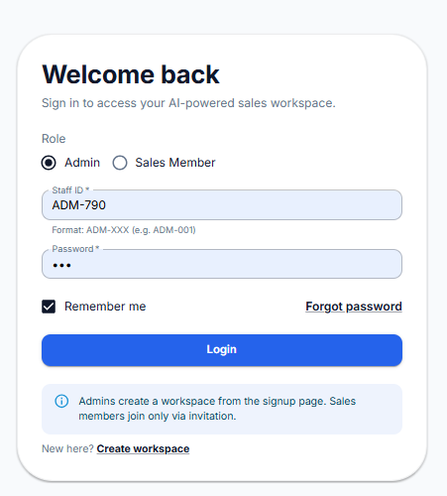
Figure 4.1. Login Screen.

4.3.2 Dashboard Interface
The dashboard provides a summary of key performance indicators relevant to the logged-in user. For administrators, it displays total leads, lead tier distribution across Hot, Warm, and Cold categories, assignment statistics, and conversion trends. For sales members, the dashboard shows a summary of their assigned leads, their current workload status, and recent lead activity.
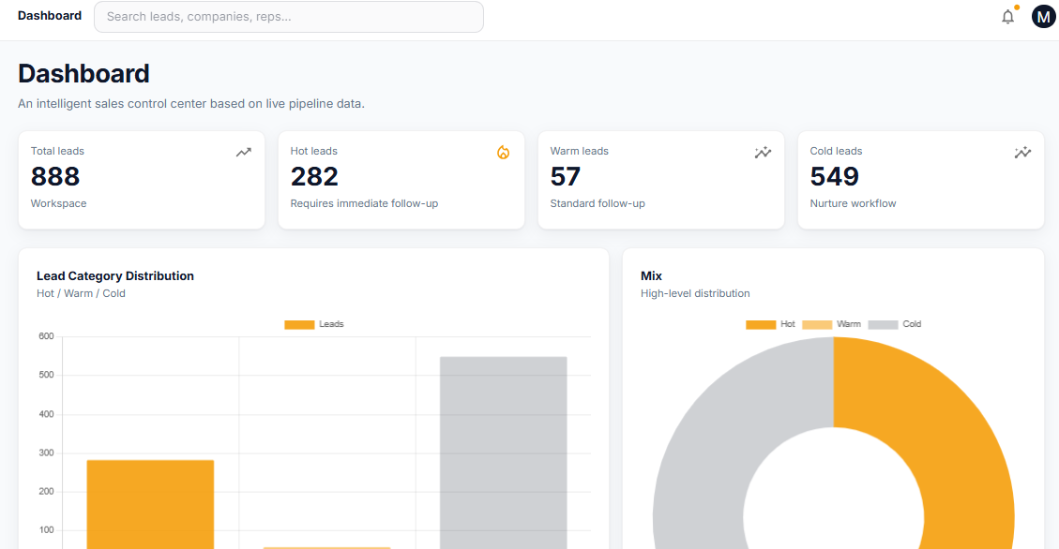
Figure 4.2. Admin Dashboard Interface.
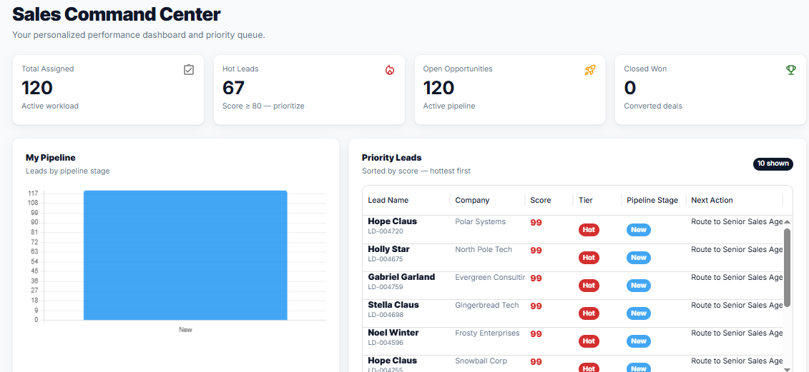
Figure 4.3. Sales Member Dashboard Interface.

4.3.3 Lead Import Interface
The lead import interface allows administrators to upload lead data in CSV or Excel format. The upload process follows a four-phase progress flow: file upload, AI scoring, validation and saving, and completion. During the AI scoring phase, the machine learning model is applied to each lead row to generate a score and tier classification. At the end of the import, a summary card displays the number of leads successfully imported and confirms that all leads have been saved with an Unassigned status, meaning no automatic routing occurs at the point of import.
The interface also supports duplicate handling, allowing the administrator to choose between updating existing lead records or skipping duplicates entirely. A downloadable CSV template is available to guide users on the required data format.
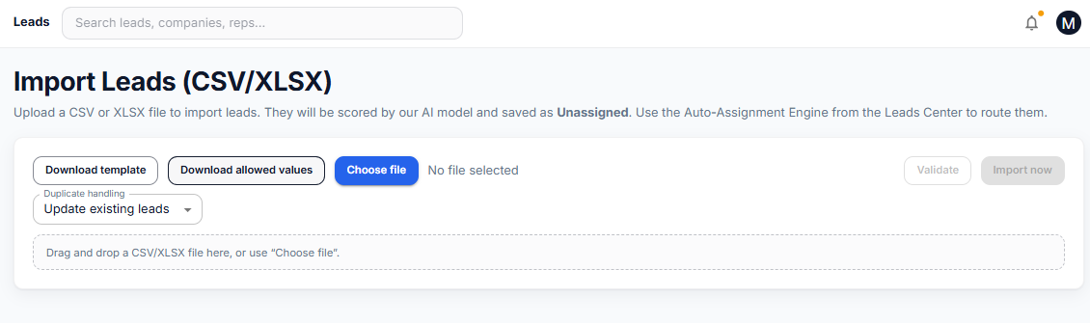
Figure 4.4. CSV Lead Import Interface.

4.3.4 Leads Center Interface
The leads center provides a full view of all imported leads. It includes key performance cards showing total lead count, tier breakdown, and assignment distribution. Below the summary cards, a searchable and filterable data table lists all leads with columns for name, company, tier, score, source, and assignment status. Clicking on a lead opens a detailed view with all lead attributes, engagement data, and the generated AI score.
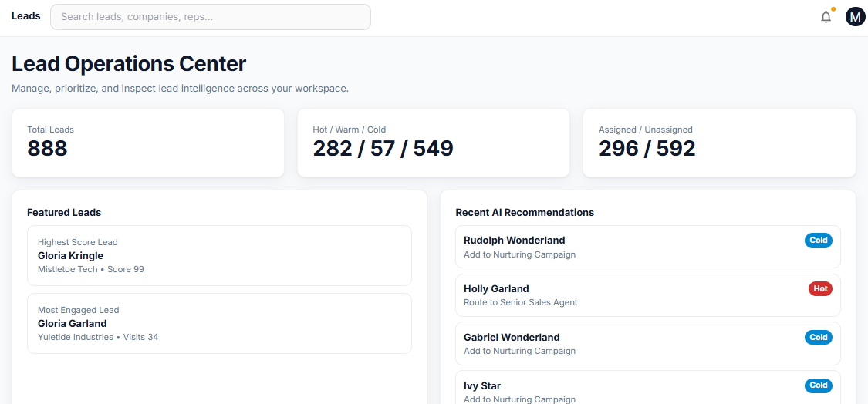
Figure 4.5. Leads Center Interface.
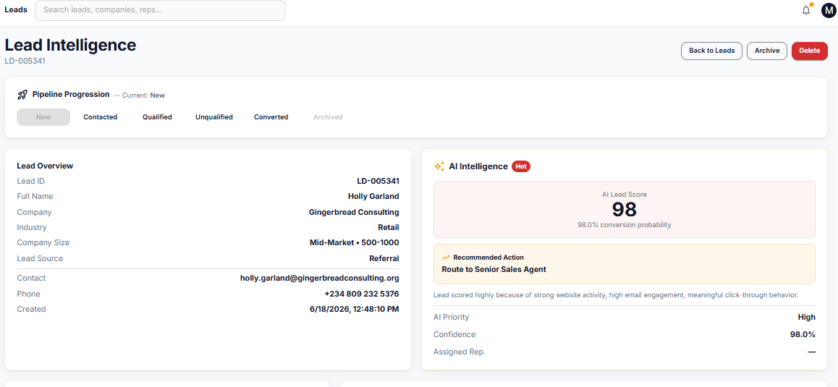
Figure 4.6. Lead Detail View.

4.3.5 Sales Team Interface
The sales team interface is accessible only to administrators. It displays a roster of all sales members with their current profile status, availability, sales profile classification, and auto-assignment opt-in status. Each member can be configured through a modal dialog that allows the administrator to set the member's sales profile, performance rating, industry specializations, availability status, and profile status. A member must be set to Active status before the routing engine will consider them eligible for lead assignment.
The interface also includes an invitation section where administrators can generate invitation links to onboard new sales members. Each generated link includes an expiry configuration and displays its current status as Pending, Used, or Accepted.
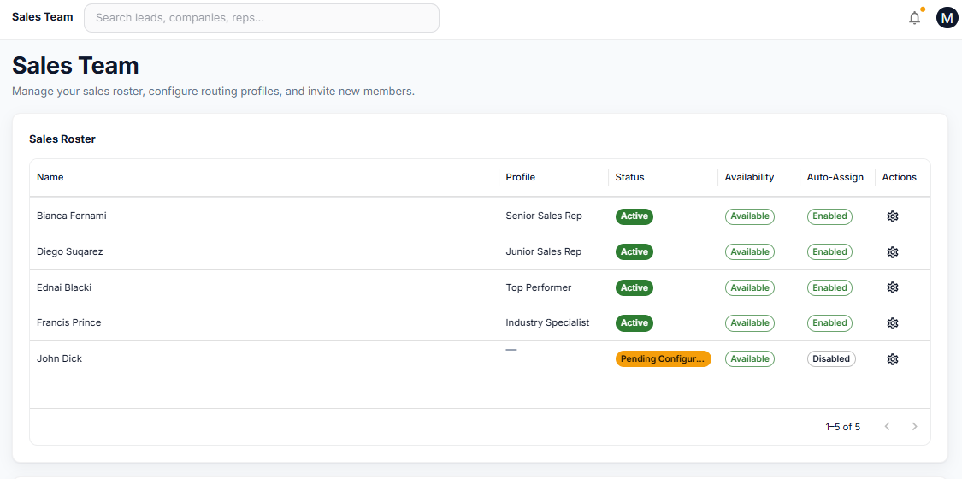
Figure 4.7. Sales Team Interface.
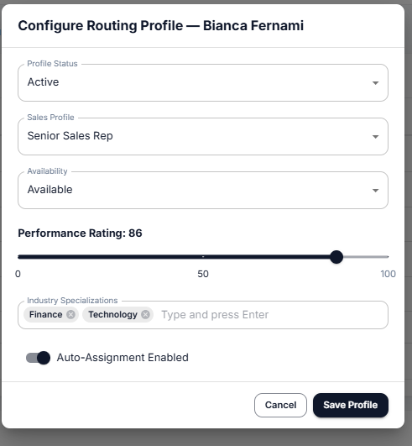
Figure 4.8. Sales Member Configuration Modal.

4.3.6 Team Management Interface
The team management interface gives administrators a real-time view of workload distribution across the sales team. Three summary cards display the total number of representatives, the total number of active lead assignments, and the average utilization rate across the team. A workload metrics table lists each sales member alongside their performance rating, current assignment count, maximum capacity, and utilization percentage. Utilization is color-coded, with green indicating a healthy workload below 70%, amber indicating a load between 70% and 89%, and red indicating a near-capacity state of 90% and above.
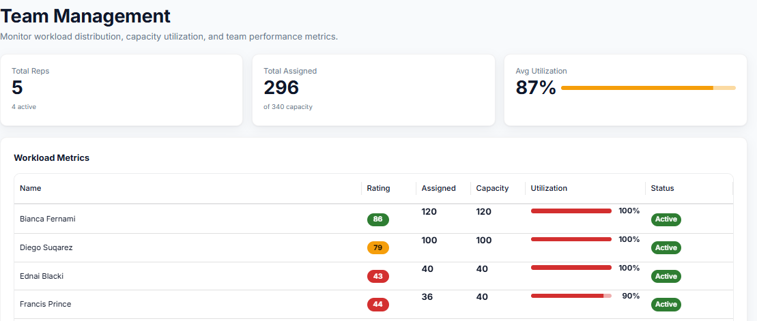
Figure 4.9. Team Management Workload Interface.

4.4 Machine Learning Results

4.4.1 Model Training Results
The Random Forest Classifier was trained on a dataset of 5,000 B2B sales lead records. The dataset was split using an 80/20 ratio, with 3,000 records used for training and 2,000 records held out for testing. The class distribution in the full dataset comprised approximately 3,269 non-converted leads (65.4%) and 1,731 converted leads (34.6%). A stratified split was applied to preserve this ratio in both the training and test sets.
The class imbalance was addressed by setting the class_weight parameter to balanced during model initialization, which automatically adjusts the weight assigned to each class inversely proportional to its frequency. The model was configured with 300 decision trees and parallel processing enabled across all available CPU cores. A fixed random seed was used to ensure that training results are reproducible.
Parameter | Value
Total Dataset Size | 5,000 records
Training Set | 3,000 records (80%)
Test Set | 2,000 records (20%)
Positive Class (Converted) | 1,731 records (34.6%)
Negative Class (Not Converted) | 3,269 records (65.4%)
Split Strategy | Stratified by target variable
Algorithm | Random Forest Classifier
Number of Trees | 300
Class Weighting | Balanced
Table 4.4
Model Training Configuration Summary

4.4.2 Performance Metrics
After training, the model was evaluated on the 1,000-record test set. Predicted outcomes were compared against the actual conversion labels to compute the standard classification metrics. Table 4.5 presents the results.
Metric | Value | Interpretation
Accuracy | 98.9% | Proportion of all leads correctly predicted
Precision | 98.0% | Of all leads predicted as converted, 98% were correct
Recall | 98.8% | Of all actual conversions, 98.8% were correctly identified
F1 Score | 98.4% | Harmonic mean of precision and recall
ROC-AUC | 99.9% | Near-perfect ability to distinguish between classes
Table 4.5
Model Performance Metrics on Hold-Out Test Set

The model achieved high performance across all five metrics. The precision of 98.0% indicates that very few non-converting leads were incorrectly predicted as likely to convert. The recall of 98.8% indicates that the model successfully identified almost all leads that would genuinely convert. The ROC-AUC score of 99.9% reflects near-perfect discriminative ability between the two classes across all possible decision thresholds.
The confusion matrix below further illustrates the prediction breakdown across the test set. Of the approximately 346 positive samples and 654 negative samples in the test set, only 4 true conversions were missed (false negatives) and only 6 non-converting leads were incorrectly flagged as conversions (false positives).
 | Predicted: Not Converted (0) | Predicted: Converted (1)
Actual: Not Converted (0) | 648 (True Negative) | 6 (False Positive)
Actual: Converted (1) | 4 (False Negative) | 342 (True Positive)
Table 4.6
Confusion Matrix on 2,000-Record Test Set
The low false positive rate of 0.9% ensures that very few unqualified leads are routed to senior sales representatives, preventing unnecessary use of high-priority resources. The low false negative rate of 1.2% ensures that genuine conversion opportunities are rarely overlooked or misclassified as low-priority leads.

4.4.3 Lead Classification Results
Following prediction, each lead is classified into one of three tiers based on the model's conversion probability output. Table 4.7 presents the tier thresholds, expected distribution across the test set, and the corresponding business actions triggered by the routing engine.
Tier | Score Range | Expected Distribution | Business Action
Hot | 80 – 100 | ~20 – 25% of leads | Immediate routing to Top Performers or Senior Representatives
Warm | 50 – 79 | ~35 – 40% of leads | Standard routing to Senior Representatives or Industry Specialists
Cold | 0 – 49 | ~35 – 45% of leads | Nurture routing to Junior Sales Representatives
Table 4.7
Lead Tier Classification and Business Actions

The tier classification directly influences the routing engine's scoring matrix, where each tier is mapped to preferred sales profiles. Hot leads receive the highest scores when matched with Top Performers, while Cold leads are directed toward Junior Sales Representatives who are better positioned to nurture and develop lower-intent prospects over time.

4.5 Prescriptive Lead Routing Results

4.5.1 Routing Logic Overview
The prescriptive lead routing engine is a rule-based assignment system that evaluates each sales representative against a given lead's characteristics and assigns the lead to the most suitable available member. The engine operates as a separate step from the import and scoring process, meaning it is only triggered when an administrator explicitly initiates routing on a set of scored, unassigned leads.
This deliberate separation between lead ingestion and lead routing ensures that administrators can review scored leads before assigning them, apply selective routing to specific subsets, and maintain full control over how and when assignments are made. The engine does not route any leads automatically at the point of import.
The routing process evaluates each eligible sales representative across four scored dimensions and one hard constraint check. The four scoring dimensions are industry specialization match, tier-to-profile preference alignment, performance rating, and capacity utilization penalty. The hard constraint check is the capacity circuit breaker, which disqualifies any representative whose current number of active assignments equals or exceeds their maximum capacity before any scoring takes place.

4.5.2 Capacity-Based Assignment
Each sales representative has a maximum assignment capacity that is determined by their performance rating. Higher-rated representatives are assigned greater capacity limits, reflecting their ability to manage a larger and more complex lead portfolio. Table 4.8 presents the capacity bands applied by the routing engine.
Performance Rating | Maximum Concurrent Assignments
90 – 100 | 150
80 – 89 | 120
70 – 79 | 100
60 – 69 | 80
50 – 59 | 60
0 – 49 | 40
Table 4.8
Performance-Based Capacity Bands

Before a representative is scored and considered for assignment, the engine checks whether their current active assignment count is less than their capacity. If the count is equal to or greater than the capacity, the representative is disqualified from receiving any new leads in that routing cycle, regardless of how high their routing score would otherwise be. If all available representatives are at full capacity, the lead remains in an unassigned state and no assignment record is created.
Table 4.9 presents the complete routing scoring dimensions and the maximum points available for each.
Scoring Dimension | Maximum Points | Basis of Scoring
Industry Specialization Match | 30 points | Exact match between lead industry and representative specialization
Tier-to-Profile Preference | 25 points | Alignment between lead tier (Hot/Warm/Cold) and sales profile type
Performance Rating | 25 points | Performance rating divided by 100, multiplied by 25
Capacity Utilization Penalty | Up to -30 points | Penalty applied when utilization exceeds 70%, 80%, or 90%
Table 4.9
Routing Score Dimensions

4.5.3 Load Balancing Mechanism
To prevent a single high-scoring representative from accumulating a disproportionate share of all assignments, the routing engine applies a proportional load balancing rule as the final selection step. After all eligible and capacity-verified representatives have been scored, the engine sorts the candidates by their current utilization rate in ascending order, with total score used as a tiebreaker in descending order. The representative with the lowest utilization rate is selected, provided their total routing score is greater than zero.
This mechanism ensures that lead assignments are distributed across the sales team in proportion to each member's available capacity. A representative with a slightly lower routing score but significantly lower utilization rate will be selected over a higher-scoring representative who is already heavily loaded. Table 4.10 illustrates how the load balancing rule works in a sample scenario.
Representative | Total Routing Score | Current Utilization | Selection Outcome
Rep A | 72 points | 80% | Not selected (high utilization)
Rep B | 65 points | 30% | Selected (lowest utilization)
Rep C | 68 points | 75% | Not selected (higher utilization than Rep B)
Table 4.10
Sample Load Balancing Outcome

In the example above, Rep B is selected despite having the lowest routing score among the three candidates, because their utilization rate is significantly lower than the others. This outcome reflects the system's priority of maintaining a balanced workload across the team over maximizing individual match scores.

4.6 System Testing and Evaluation
The system was tested across multiple layers to verify that each component behaves correctly both in isolation and as part of the complete end-to-end workflow. The testing approach covered authentication, lead import, AI scoring, role-based access control, capacity enforcement, and full pipeline validation. Table 4.11 provides a summary of the test cases executed and their outcomes.

Test Case | Description | Expected Result | Status
User Authentication | Valid staff ID, password, and role submitted | JWT issued and user redirected to dashboard | Passed
Role Mismatch Rejection | Correct credentials submitted with wrong role | HTTP 401 returned with role mismatch message | Passed
Admin Registration | New admin registers with organization name | Organization and admin account created | Passed
Sales Member Invitation | Admin generates invitation link for new sales member | Signed invitation link created with expiry | Passed
CSV Import | 1000-row CSV file uploaded by admin | All sucessul leads scored and saved as Unassigned | Passed
Import Isolation | CSV import completed with active sales members available | No lead assignment records created during import | Passed
AI Lead Scoring | Lead row processed during import | Conversion probability and tier generated correctly | Passed
Full Capacity Block | All sales members at maximum assignment capacity | Lead remains Unassigned, no assignment record created | Passed
Partial Capacity Routing | Mix of available and at-capacity representatives | Lead assigned to representative with available capacity | Passed
Profile Status Filter | One active rep and one pending configuration rep available | Only active rep considered for assignment | Passed
RBAC Enforcement | Sales member attempts to access admin-only endpoints | HTTP 403 returned for all restricted endpoints | Passed
Dashboard Statistics | Admin views dashboard after import and assignment | Correct lead counts and tier distribution displayed | Passed
End-to-End Workflow | Full cycle from admin registration to lead assignment | All stages completed successfully in sequence | Passed
Table 4.11
System Test Cases and Results
All test cases passed successfully. The import isolation test confirmed that no assignment records are created during the CSV import process, maintaining the intended separation between lead ingestion and routing. The capacity enforcement tests confirmed that the circuit breaker correctly blocks over-assignment regardless of how high a representative's routing score is. The RBAC tests confirmed that sales members are unable to access or invoke any admin-only functionality through direct API calls.

4.7 Discussion of Findings
The implementation produced a fully functional Intelligent Sales Automation SaaS platform that addresses the objectives defined in Chapter 1. The system demonstrated the ability to ingest large volumes of lead data, apply machine learning-based scoring to each lead, and route assignments to the most suitable sales representatives based on structured evaluation criteria.
The machine learning model achieved a test accuracy of 98.9% and a ROC-AUC score of 99.9%, which indicates a high degree of predictive reliability. These results support the use of the Random Forest Classifier for binary lead conversion prediction on structured B2B sales data. The model's balanced weighting approach effectively handled the natural class imbalance in the dataset, where non-converting leads outnumber converting leads by approximately 2:1.
The prescriptive lead routing engine performed as designed across all test scenarios. The capacity circuit breaker successfully prevented over-assignment in full-capacity conditions, and the load balancing mechanism distributed leads proportionally rather than concentrating assignments on a single high-scoring representative. This outcome is significant because it reflects a realistic team management concern in sales operations, where workload balance directly affects both individual performance and overall team morale.
The role-based access control implementation effectively enforced the intended permission boundaries between administrators and sales members. Administrators retained full control over lead import, team configuration, and routing operations, while sales members were restricted to viewing and acting on their own assigned leads. This separation reduces the risk of unauthorized data access and ensures that the system's automation logic cannot be bypassed by end users.
One observed limitation relates to the invitation-based onboarding process. While this approach ensures controlled access, it places additional administrative overhead on the administrator who must manually generate and distribute invitation links for each new sales member. A more streamlined onboarding flow could reduce this friction in larger organizations. Additionally, the current routing engine operates synchronously within a single request cycle, which may introduce latency when processing large batches of leads in a single routing operation.
Overall, the implemented system meets the functional and technical objectives of the project. The combination of machine learning lead scoring, prescriptive routing, capacity management, and role-based access control demonstrates that an intelligent and automated approach to B2B lead management is both technically feasible and operationally practical at the scale tested.

4.8 Chapter Summary
This chapter presented the full implementation of the Intelligent Sales Automation SaaS platform, covering the development environment, system components, machine learning pipeline, interface design, and testing outcomes.
The development environment was configured using Python, Node.js, and PostgreSQL alongside supporting libraries selected for the frontend, backend, and machine learning requirements of the system. The frontend was implemented as a role-aware React single-page application providing distinct functional environments for administrators and sales members. The backend, built with FastAPI, manages authentication, lead data processing, routing logic, and dashboard reporting through a structured set of API modules.
The machine learning pipeline applies a trained Random Forest Classifier to score incoming leads and classify them into Hot, Warm, and Cold tiers based on predicted conversion probability, achieving 98.9% accuracy and a ROC-AUC of 99.9% on the hold-out test set. The prescriptive routing engine assigns leads to the most suitable available sales member using a four-dimension scoring system, combined with a hard capacity circuit breaker and proportional load balancing. System testing confirmed that all major workflows operate correctly, including import isolation, capacity enforcement, role-based access control restrictions, and end-to-end lead lifecycle management.
The discussion of findings addressed both the strengths of the implemented system and areas where further refinement could improve scalability and administrative efficiency. Chapter Five will present the project conclusion, summarising achievements, limitations, and recommendations for future development.

CHAPTER FIVE

SUMMARY, CONCLUSION AND RECOMMENDATIONS

5.1 Summary and Conclusion
This study focused on the development of an Intelligent Sales Automation SaaS platform designed to improve lead management through predictive analytics and workflow automation. The research was motivated by the limitations of manual lead qualification, inconsistent lead prioritisation, and the limited use of intelligent decision-support capabilities in traditional sales operations.
The Design Science Research paradigm was adopted as the overarching research framework, with Agile methodology guiding software development and the CRISP-DM framework directing the machine learning component. A Random Forest Classifier was trained on historical B2B sales lead data to predict lead conversion likelihood, forming the predictive core of the platform. The developed system integrates lead scoring, classification, workflow automation, and analytics within a web-based SaaS environment, enabling organisations to prioritise leads more effectively, automate sales processes, and support data-driven decision-making.
The study successfully achieved its objectives. The Random Forest model demonstrated strong predictive performance, while the workflow automation engine reliably executed lead routing and assignment based on classification outcomes. The integration of these components into a unified platform provides a practical solution for organisations seeking to reduce manual sales effort, improve response times, and concentrate resources on leads with the highest conversion potential. The implementation and evaluation results confirm that combining machine learning with prescriptive workflow automation offers a viable and effective approach to improving lead management and sales efficiency.

5.2 Recommendations
Based on the findings of this study, the following recommendations are proposed:
- Organizations seeking to improve sales efficiency should consider adopting intelligent lead scoring systems to support data-driven lead prioritization.
- Future implementations of the system should incorporate real-time integrations with Customer Relationship Management (CRM) platforms and marketing automation tools to enhance interoperability.
- Additional machine learning algorithms such as Gradient Boosting, XGBoost, and Neural Networks may be explored and compared with the Random Forest model to determine the most effective predictive approach.
- Future versions of the system should support automated communication channels such as email and SMS follow-up campaigns to further enhance workflow automation capabilities.
- Larger and more diverse datasets should be utilized in future studies to improve model generalization and predictive performance across different industries and sales environments.

5.3 Suggestions for Further Research
Future research may focus on extending the capabilities of intelligent sales automation systems through advanced artificial intelligence techniques. Areas for further investigation include:
- Explainable Artificial Intelligence (XAI) for transparent lead scoring decisions.
- Reinforcement learning for adaptive sales workflow optimization.
- Real-time predictive analytics using streaming lead data.
- Customer churn prediction and retention analytics.
- Integration of generative AI assistants for sales support and customer engagement.

References
Al Kalach, N. (2025). AI-driven customer relationship management: Enhancing Salesforce efficiency through predictive analytics. International Journal of Advance Industrial Engineering, 13(1), 21–38.
Armstrong, G., Kotler, P., Harker, M., & Brennan, R. (2018). Marketing: An introduction (4th European ed.). Pearson.
Beck, K., Beedle, M., Van Bennekum, A., Cockburn, A., Cunningham, W., Fowler, M., Grenning, J., Highsmith, J., Hunt, A., Jeffries, R., Kern, J., Marick, B., Martin, R. C., Mellor, S., Schwaber, K., Sutherland, J., & Thomas, D. (2001). Manifesto for agile software development. https://agilemanifesto.org/
Breiman, L. (2001). Random forests. Machine Learning, 45(1), 5–32. https://doi.org/10.1023/A:1010933404324
Buttle, F., & Maklan, S. (2019). Customer relationship management: Concepts and technologies (4th ed.). Routledge.
Chapman, P., Clinton, J., Kerber, R., Khabaza, T., Reinartz, T., Shearer, C., & Wirth, R. (2000). CRISP-DM 1.0: Step-by-step data mining guide. SPSS Inc.
Chaffey, D., & Ellis-Chadwick, F. (2019). Digital marketing: Strategy, implementation and practice (7th ed.). Pearson Education Limited.
Chatterjee, S., Ghosh, S. K., Chaudhuri, R., & Nguyen, B. (2019). Are CRM systems ready for AI integration? A conceptual framework of organizational readiness for effective AI–CRM integration. The Bottom Line, 32(2), 144–157. https://doi.org/10.1108/BL-02-2019-0069
Duarte, C., Fischer, L., & Sakamoto, H. (2023). Emerging trends in AI-powered sales automation and CRM systems for global enterprises. International Journal of Advanced Computer Science and Applications, 2(12), 1–16.
Gartner. (2021). Future of B2B sales. Gartner Research.
Han, J., Kamber, M., & Pei, J. (2022). Data mining: Concepts and techniques (4th ed.). Morgan Kaufmann.
Hevner, A. R., March, S. T., Park, J., & Ram, S. (2004). Design science in information systems research. MIS Quarterly, 28(1), 75–105.
Kihu, A., O'Connor, M., Wu, S., & Bazakas-Chamberlain, W. (2022). Development of predictive and prescriptive analytical models using customer, revenue, and usage data (Undergraduate Major Qualifying Project). Worcester Polytechnic Institute.
Kotler, P., & Keller, K. L. (2016). Marketing management (15th ed.). Pearson Education.
Laaksonen, H. (2024). Improving customer retention with marketing and sales integrated lead management: Case Finnish B2B consulting company (Master's thesis, Lappeenranta-Lahti University of Technology). LUTPub.
Laudon, K. C., & Laudon, J. P. (2020). Management information systems: Managing the digital firm (16th ed.). Pearson.
Lepenioti, K., Bousdekis, A., Apostolou, D., & Mentzas, G. (2020). Prescriptive analytics: Literature review and research challenges. International Journal of Information Management, 50, 57–70. https://doi.org/10.1016/j.ijinfomgt.2019.04.003
Marr, B. (2016). Big data in practice: How 45 successful companies used big data analytics to deliver extraordinary results. Wiley.
McKinsey & Company. (2022). Next-gen B2B sales. McKinsey & Company.
Neursu, V. M. K., Vuyyuru, R. K. R., & Kilaru, K. (2025). From data to decisions: AI in SaaS product analytics and customer experience optimization. Sarconcill Journal of Public Administration and Management, 4(2), 1–8.
Paschen, J., Wilson, M., & Ferreira, J. (2020). Collaborative intelligence: How human and artificial intelligence create value along the B2B sales funnel. Business Horizons, 63(3), 403–414. https://doi.org/10.1016/j.bushor.2020.01.003
Provost, F., & Fawcett, T. (2013). Data science for business: What you need to know about data mining and data-analytic thinking. O'Reilly Media.
Rackham, N. (1988). SPIN selling. McGraw-Hill.
Sangam, G. K. (2026). AI-powered lead scoring and opportunity management in Salesforce CRM. The American Journal of Engineering and Technology, 8(1), 120–125. https://doi.org/10.37547/tajet/v8i1-314
Sommerville, I. (2016). Software engineering (10th ed.). Pearson Education.
Sova, A. (2026). Leveraging artificial intelligence in SaaS customer relationship management: A qualitative content analysis of customer stories from CRM system vendors (Master's thesis, University of Turku).
Trussler, J. (2025). Modern sales methodologies and strategies for B2B organizations focused on digital products (Bachelor's thesis, Haaga-Helia University of Applied Sciences).
Witten, I. H., Frank, E., Hall, M. A., & Pal, C. J. (2016). Data mining: Practical machine learning tools and techniques (4th ed.). Morgan Kaufmann.

